Rayan Arshed

Just IT |Data Cohort 1 – DFEw4 |28/09/2023

Data Visualization Assignment 1

Excel and Tableau

Contents

First Task 2

Policies and Procedures 2

Second Task – Working with Excel 3

1 – Set a Password 3

2 – Change Data to Display Pounds 4

3 – Convert GDP Sheet into Table 5

4 – Filter for Information from 2019 6

5 – Rank, Country, and GDP per Capita Chart 7

6 – Using Creative Skills to Edit the Chart 8

7 – Move the Chart to a New Sheet 9

8 – Sort the Top 20 Ranked Countries 10

9 – Bar Chart Showing the 20 Highest Ranking Countries 11

10 – Colouring the Background of the Chart 12

11 – Create Copy Macro 13

12 – Pasting the Results of the Macro 16

13 – Saving the File 18

14 to 17 – Adding Header and Footer to Table 19

18 to 19 – Finalising and Saving 20

Third Task – Working with Tableau 21

1 – Importing Data 21

2 – Setting Relationships between Worksheets 22

3 – Check Data Types 23

4 + 5 – Building Charts 24

6 – Creating The Dashboard 33

Reflective 39

# First Task

## Policies and Procedures

When working with data, multiple policies need to be followed to ensure proper and correct handling of the data, as well as for security reasons when working with confidential or sensitive data. These include following legal and ethical principles with handling data, following a company’s data protection policy to ensure that data is not handled or used outside of scenarios agreed to by the data source (such as using user data outside of what they signed up for), and preventing potential data breaches by limiting access to the data via security processes such as password protection, and limited file authorisation and sharing.

These policies and processes need to be adhered to prevent improper and unauthorised handling of the data, and it is our responsibility as data analysts to follow these procedures to protect our clients, fellow employees, and end users. Not following these procedures could pose a security risk to our clients or to our business, ethical and mistrust concerns for the handling of data, and in extreme cases, severe safety risks for end users, or legal liabilities for the companies we work for, hence why we must be aware of them. As such, we as data analysts must do our utmost to protect the data we work with and follow all data protection policies for everyone’s sake.

Following these policies and procedures will protect anyone involved with the data, either handling the data, or the information of people within the data. As such, these guidelines must be strictly followed.

# Second Task – Working with Excel

## 1 – Set a Password

Upon opening the workbook, a Password can be set to protect the workbook from any unauthorised access. To do so, Protect Workbook under Review can be selected:

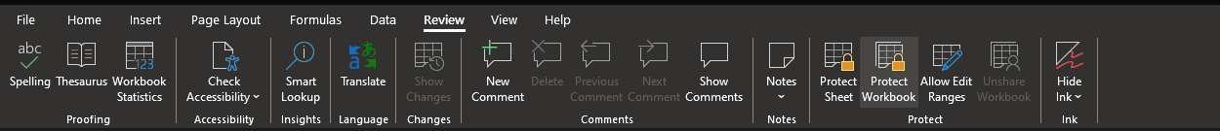

Upon selecting, a password can be set to protect the workbook:

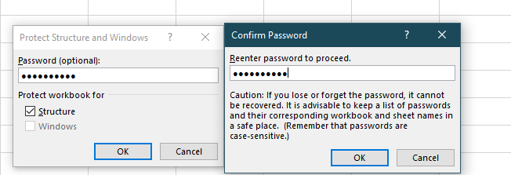

To verify the workbook is now protected, the padlock icon will stay illuminated, and selecting Protect Workbook a second time will prompt entering the password to unprotect the workbook:

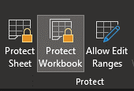 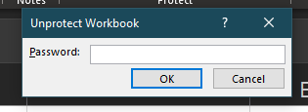

While here, it is worth being diligent to check if the workbook has any null values; using Shift + Ctrl + Arrow Keys to select the full range of data on each sheet, and using Go To Special – Blanks resulted in 0 results, meaning the worksheet should have no empty null values:

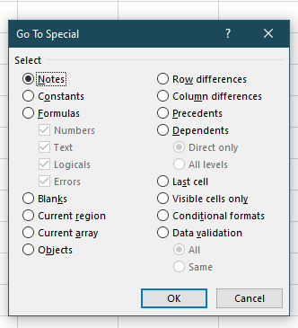 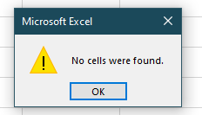

## 2 – Change Data to Display Pounds

Selecting Column C highlights the whole column, which then allows the option to change the displayed units:

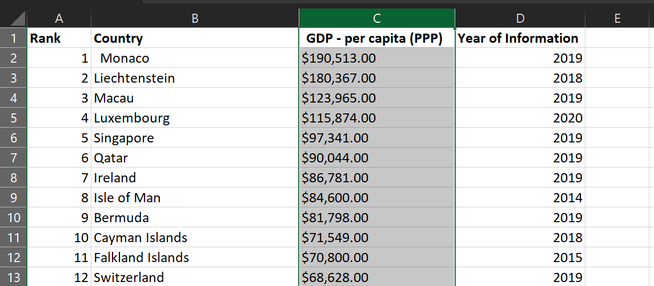

Heading to the Number section under Home brings up a dropdown where the data format can be changed, in this case we wish to set the values to Pounds, as this version of Excel is localised to the UK version, the conversion happens automatically when selecting currency:

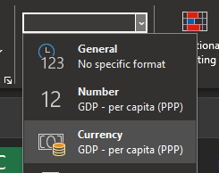

This converts the whole column into Pounds:

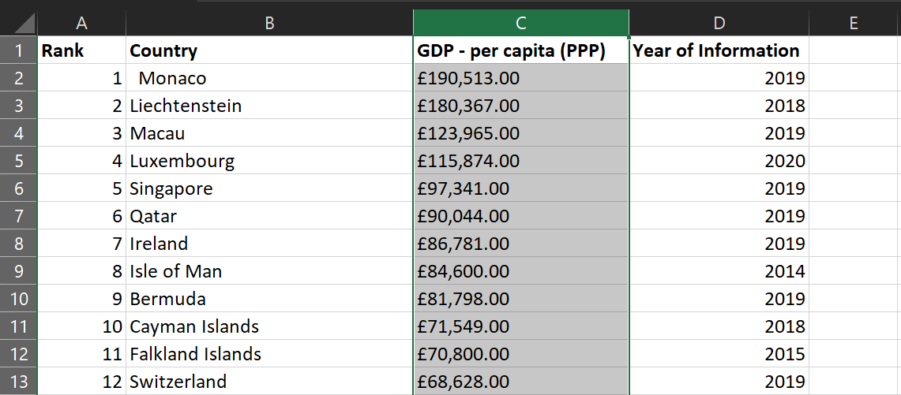

## 3 – Convert GDP Sheet into Table

To quickly highlight the whole worksheet of values, Shift + Ctrl + Arrow keys can be used to highlight the whole data area, automatically selecting the relevant data:

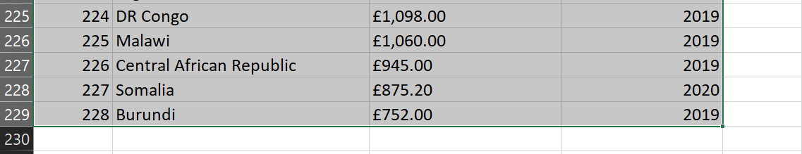

With this done, Insert – Table can be selected, and the range will be auto-filled:

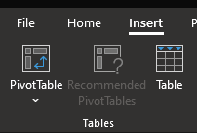 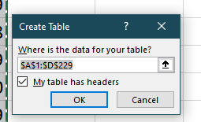

Selecting OK turns this sheet into a full table:

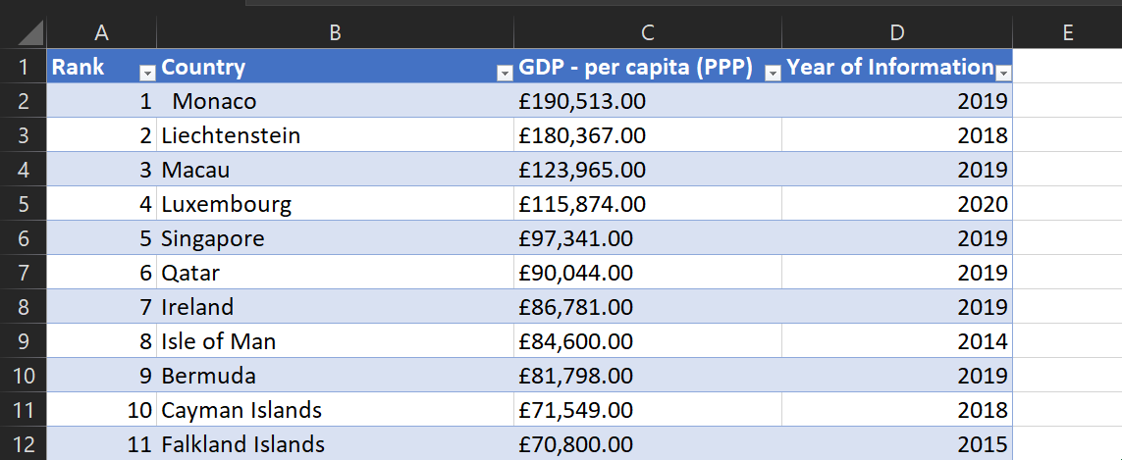

## 4 – Filter for Information from 2019

With the worksheet successfully converted into a table with headings, filters can easily be applied to the table now. Using the dropdown menu under Year of Information, 2019 can be selected, to show only information values from 2019:

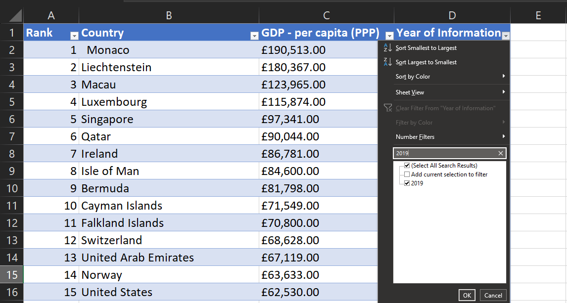

This returns a shortened table that looks like so:

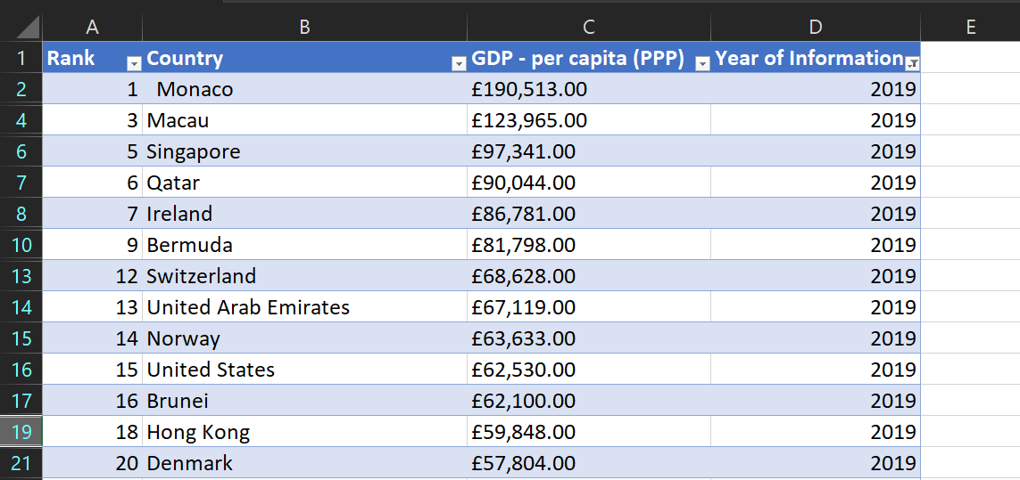

## 5 – Rank, Country, and GDP per Capita Chart

To create a chart for this dataset, a Bar Chart would be suitable, as a comparison is being made across countries with their GDP value on the Y axis. Highlighting the Rank, Country, and GDP columns, and then selecting Recommended Charts – All Charts brings up the menu from which Bar Chart can be selected:

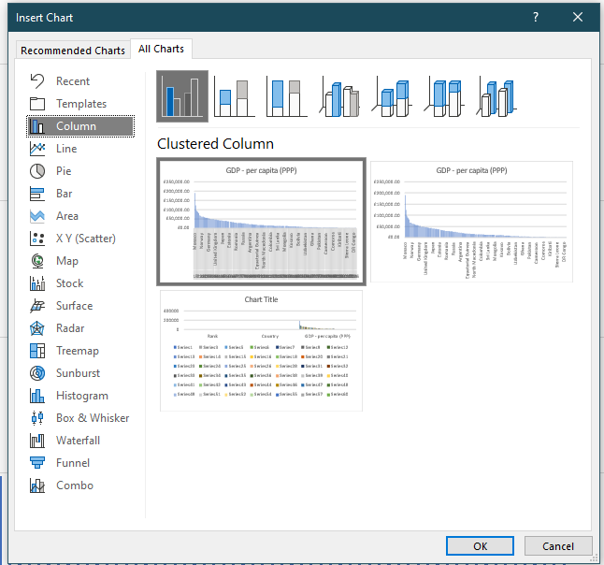

Upon selecting this, and resizing the chart, the result is as follows:

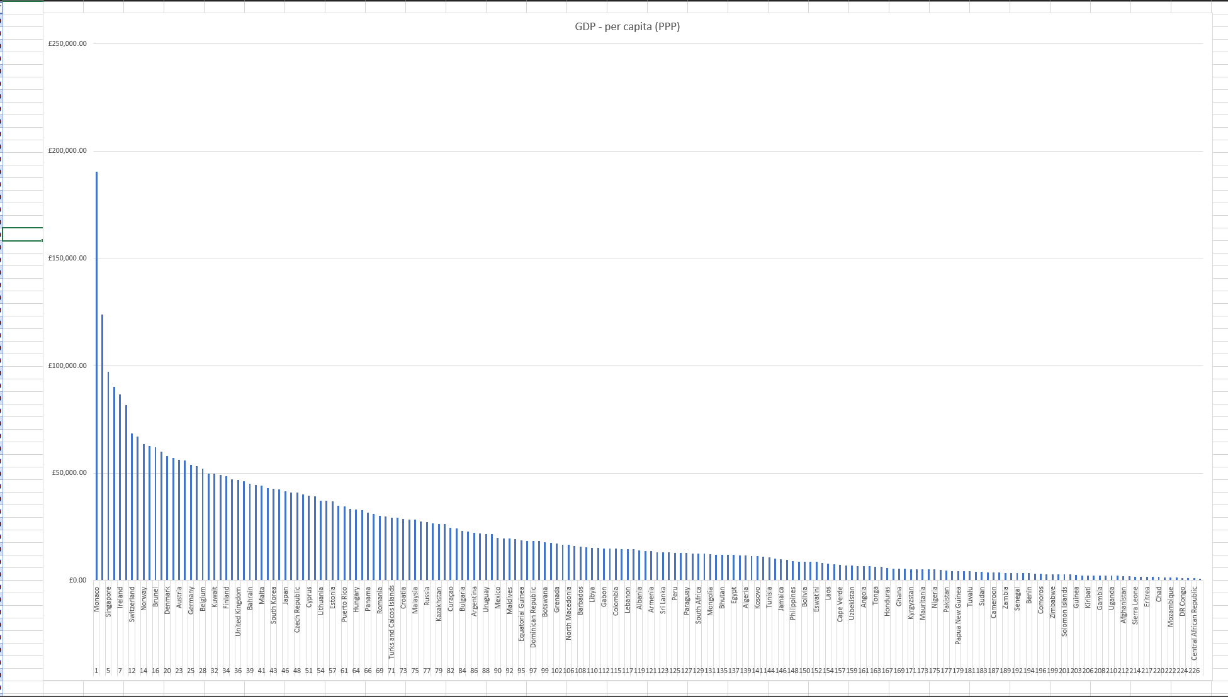

This graph is heavily detailed and fairly cramped in the labels section, so this will need to be tweaked and tidied up to make it visually appealing and understandable.

## 6 – Using Creative Skills to Edit the Chart

To begin with, the chart has been stretched to fill a full monitor screen, which allows for slightly easier reading of the X Axis:

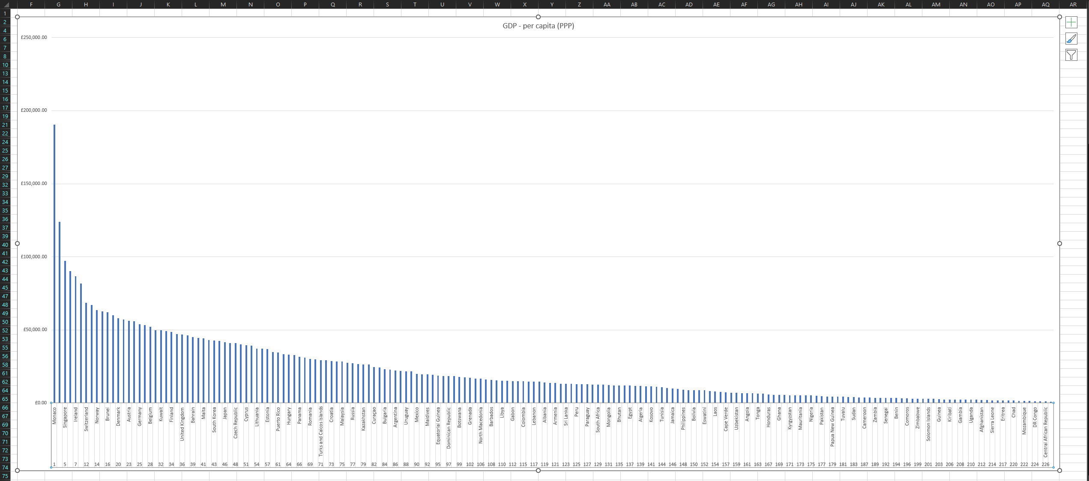

Unfortunately, due to the sheer size of the chart, it is difficult to show every single value in the X axis, so instead gridlines can be added for slightly more clarity. The colour of the chart has also been changed, and axis labels have been added, resulting in this chart:

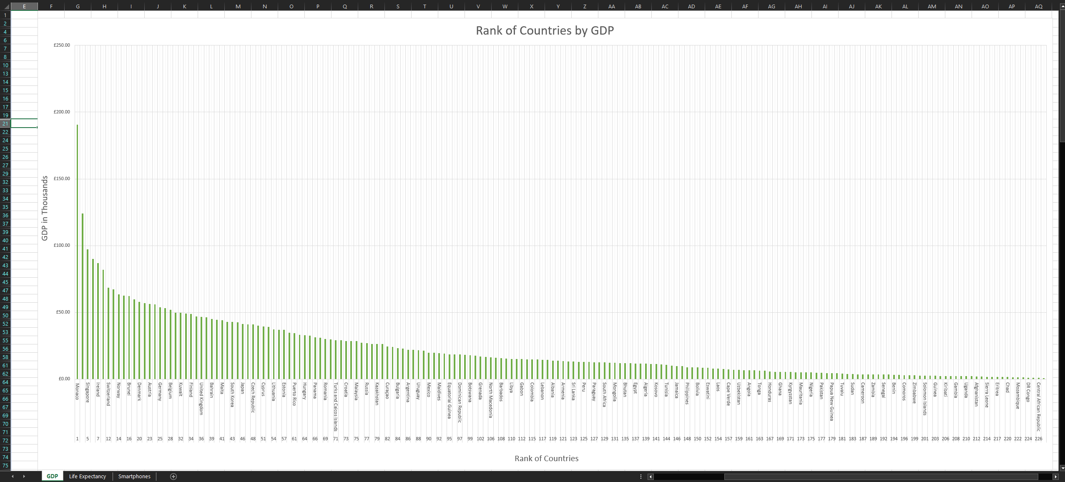

## 7 – Move the Chart to a New Sheet

To edit the format of the Workbook, the book must be unprotected, so that has been done. A new sheet has been added, titled Rank of Countries by GDP, containing the chart:



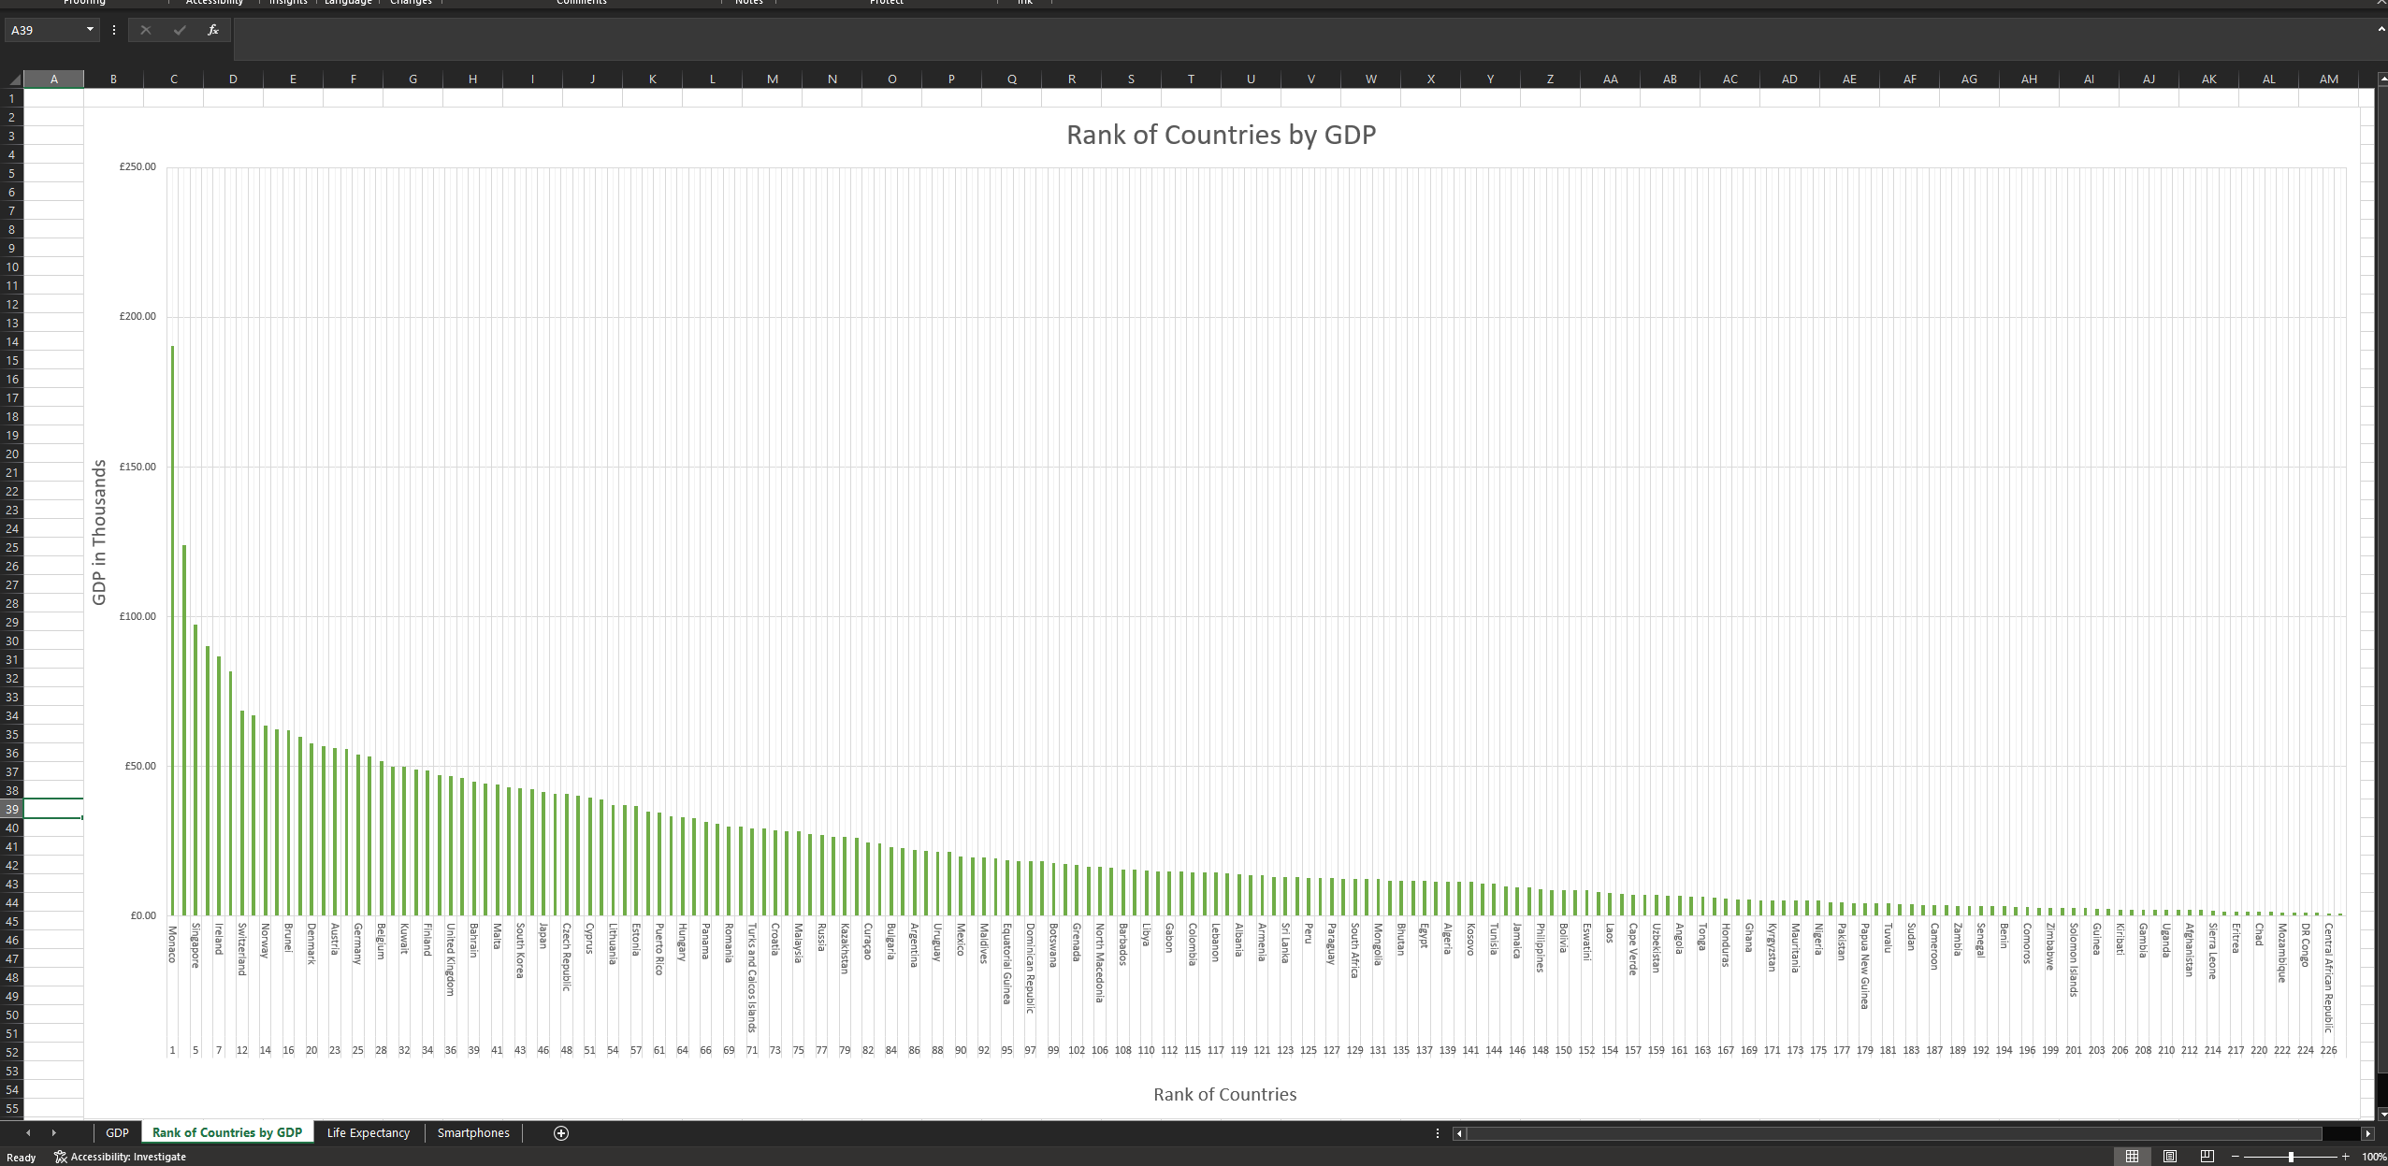

(Image has been rotated for better page fit; it is the same chart as the previous question)

## 8 – Sort the Top 20 Ranked Countries

While the 2019 filter is still active, a filter can be applied to the rank to sort them. As the rank is inverse to the GDP (meaning low rank = high GDP; ranked 1 = best GDP), a bottom sort can be used by selecting the dropdown filter icon, then number filters, and then Top 10, which opens the Rank sort window. In here, Bottom 20 items can be selected to return the 20 highest ranked values in GDP:

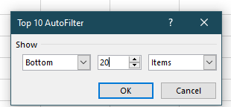

Selecting this sort results in this table:

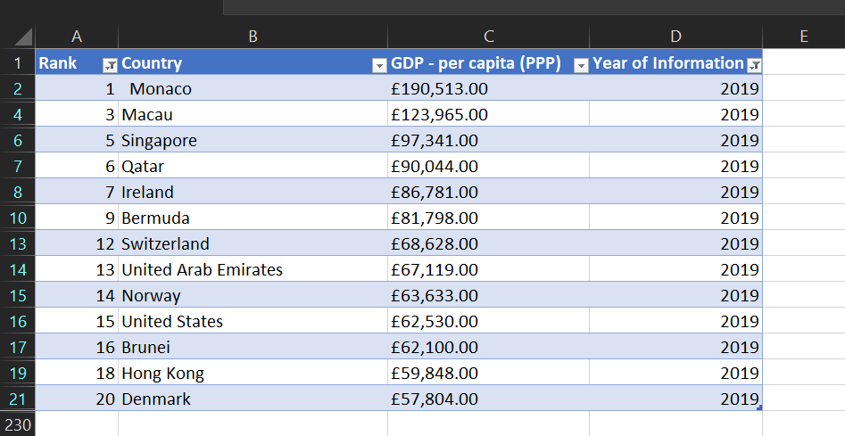

While this table does not show 20 values, that is because the sort for 2019 is still active, therefore of the top 20 values in the table, only the values from 2019 are being selected. If the 2019 filter was removed, then the table would show a total of 20 values, however the filter for 2019 will be left on in this case as it has not been specified in the assignment requirements to be disabled, and an example image used later shows this exact result.

## 9 – Bar Chart Showing the 20 Highest Ranking Countries

Below this table, a bar chart will be created to visualize this data. A clustered Bar Chart has been used, which shows the Rank and Country plotted against GDP:

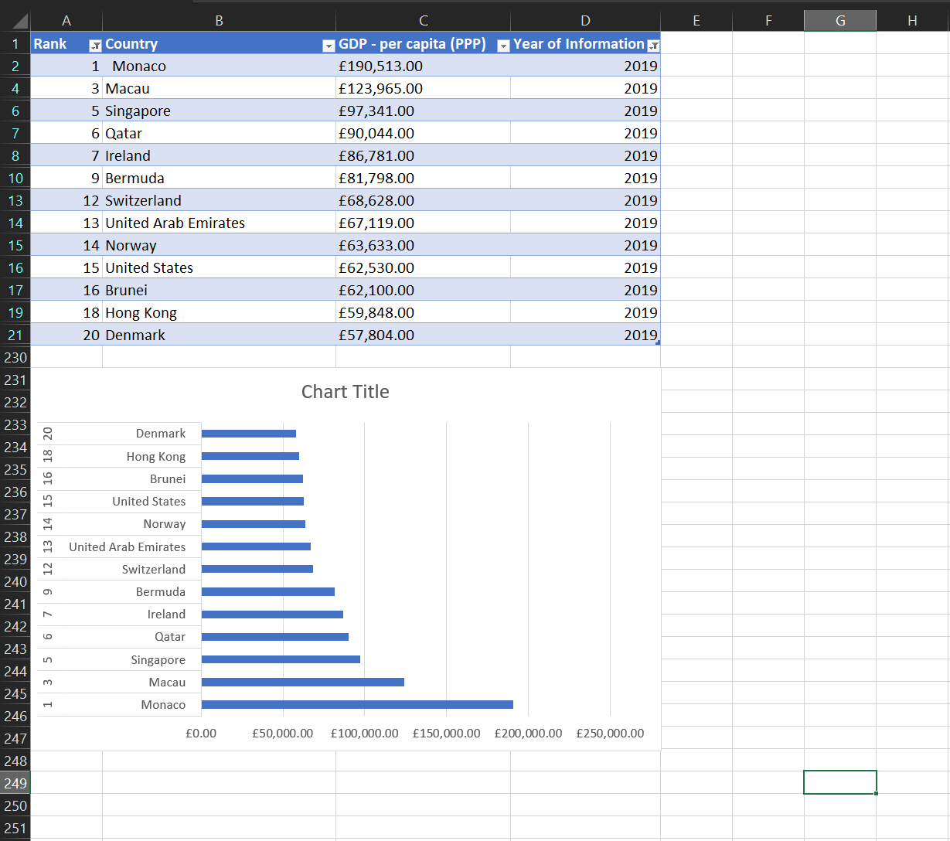

## 10 – Colouring the Background of the Chart

Highlighting the area behind the chart, the fill colour for the worksheet cells can be selected. In this case, the background has been coloured in a soft green to aesthetically match the colour of the previously generated chart in task 6:

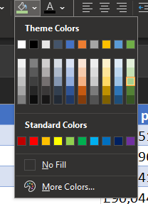 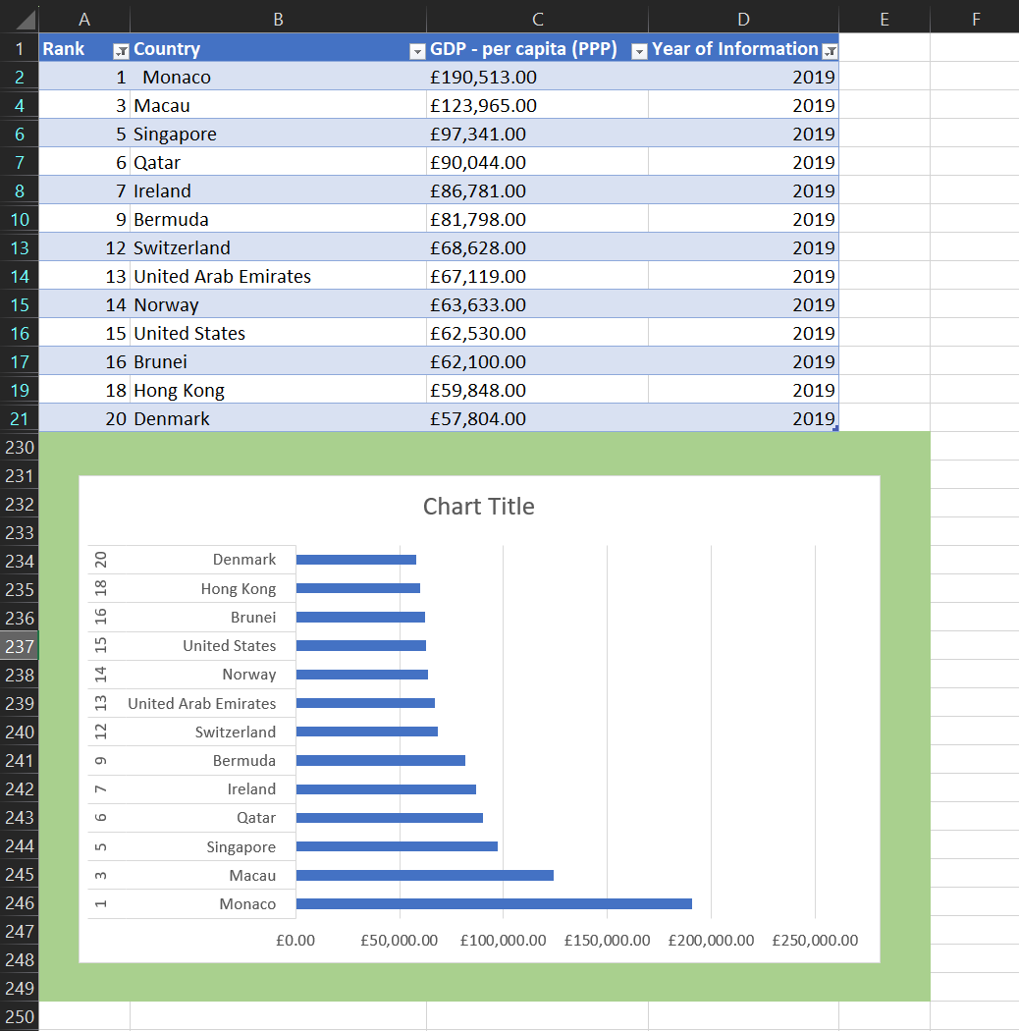

## 11 – Create Copy Macro

Three macro buttons will now be created. To do so, a Copy macro will be created first.

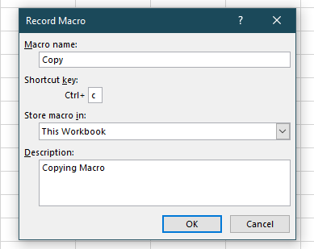

This macro selects the table and chart from the work sheet and then copies it, it has now been saved as a macro and can be run whenever:

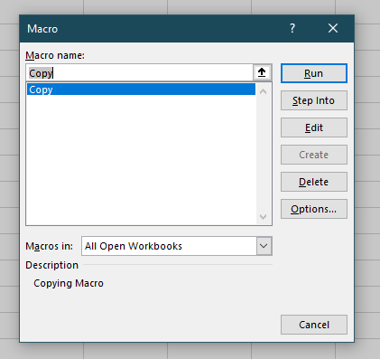

Now that a single macro has been created, the buttons can be created next. This is simply done by inserting shapes that will function as buttons for these macros:

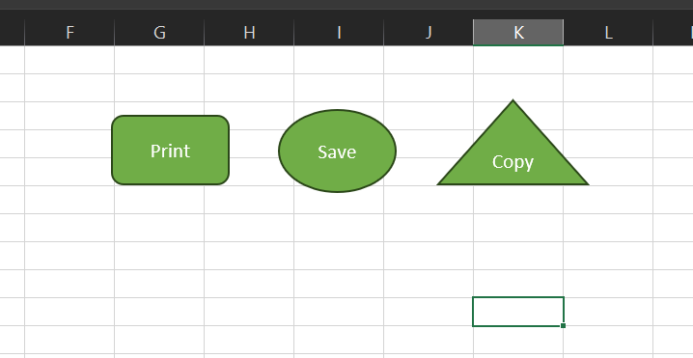

Then, after right clicking on a shape, Assign Macro can be selected, and the Copy Macro can be assigned to the triangle:

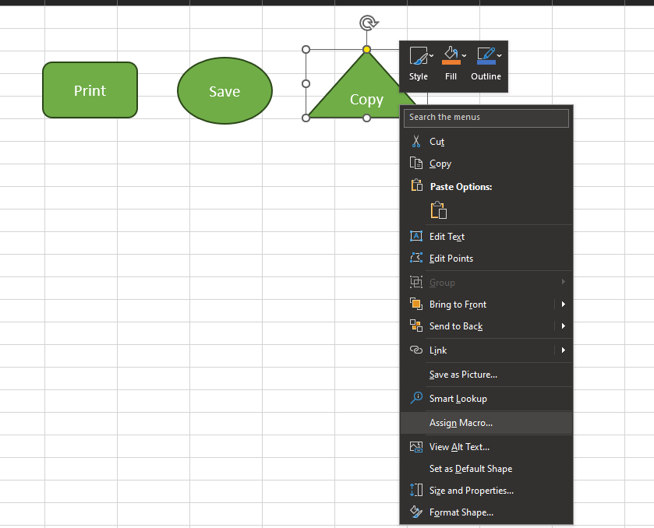

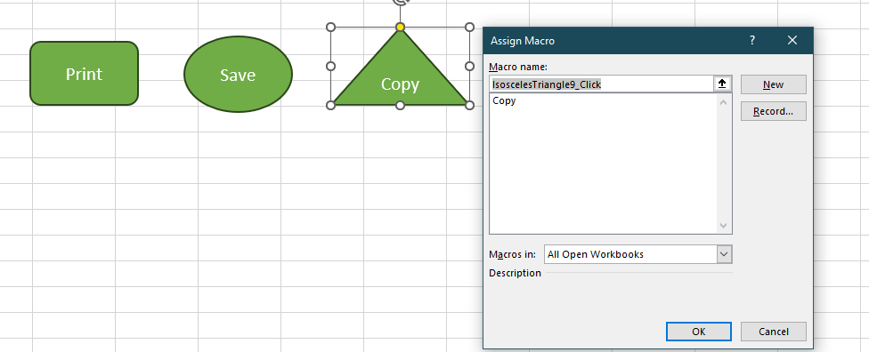

To make this work, the file had to be changed to an .xlsm file, however now the button can be selected and will copy the table and chart:

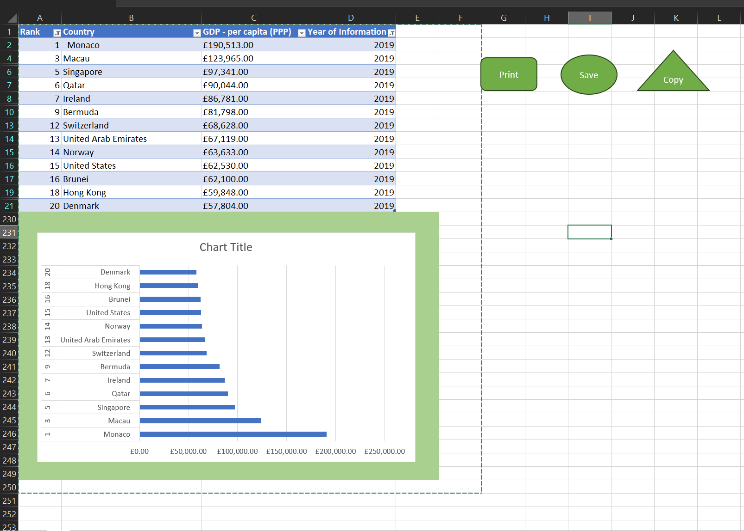

## 12 – Pasting the Results of the Macro

With the macro buttons done, the result can now be checked and tested. To test, the results can be pasted into a new Word document and titled. This pasted result will be shown below:

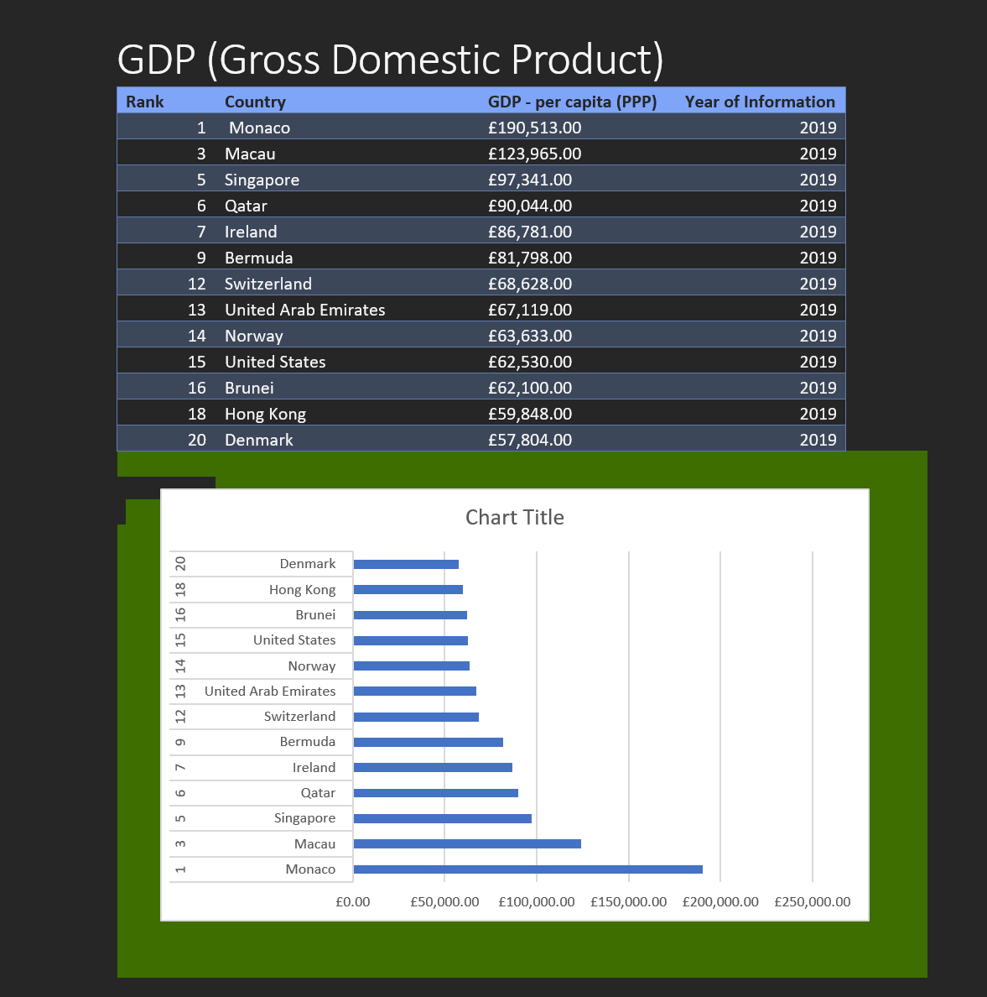

And for transparency, the result will also be pasted on the next page of this document:

|  |  |  |  |  |  |
| --- | --- | --- | --- | --- | --- |
| **Rank** | **Country** | **GDP - per capita (PPP)** | **Year of Information** |  |  |
| 1 | Monaco | £190,513.00 | 2019 |  |  |
| 3 | Macau | £123,965.00 | 2019 |  |  |
| 5 | Singapore | £97,341.00 | 2019 |  |  |
| 6 | Qatar | £90,044.00 | 2019 |  |  |
| 7 | Ireland | £86,781.00 | 2019 |  |  |
| 9 | Bermuda | £81,798.00 | 2019 |  |  |
| 12 | Switzerland | £68,628.00 | 2019 |  |  |
| 13 | United Arab Emirates | £67,119.00 | 2019 |  |  |
| 14 | Norway | £63,633.00 | 2019 |  |  |
| 15 | United States | £62,530.00 | 2019 |  |  |
| 16 | Brunei | £62,100.00 | 2019 |  |  |
| 18 | Hong Kong | £59,848.00 | 2019 |  |  |
| 20 | Denmark | £57,804.00 | 2019 |  |  |
|  |  |  |  |  |  |
| |  | | --- | |  | |  |  |  |  |  |
|  |  |  |  |  |  |
|  |  |  |  |  |  |
|  |  |  |  |  |  |
|  |  |  |  |  |  |
|  |  |  |  |  |  |
|  |  |  |  |  |  |
|  |  |  |  |  |  |
|  |  |  |  |  |  |
|  |  |  |  |  |  |
|  |  |  |  |  |  |
|  |  |  |  |  |  |
|  |  |  |  |  |  |
|  |  |  |  |  |  |
|  |  |  |  |  |  |
|  |  |  |  |  |  |
|  |  |  |  |  |  |
|  |  |  |  |  |  |
|  |  |  |  |  |  |
|  |  |  |  |  |  |

## 13 – Saving the File

The word document has been saved as Word Gross Domestic Product Report 1:

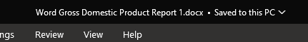

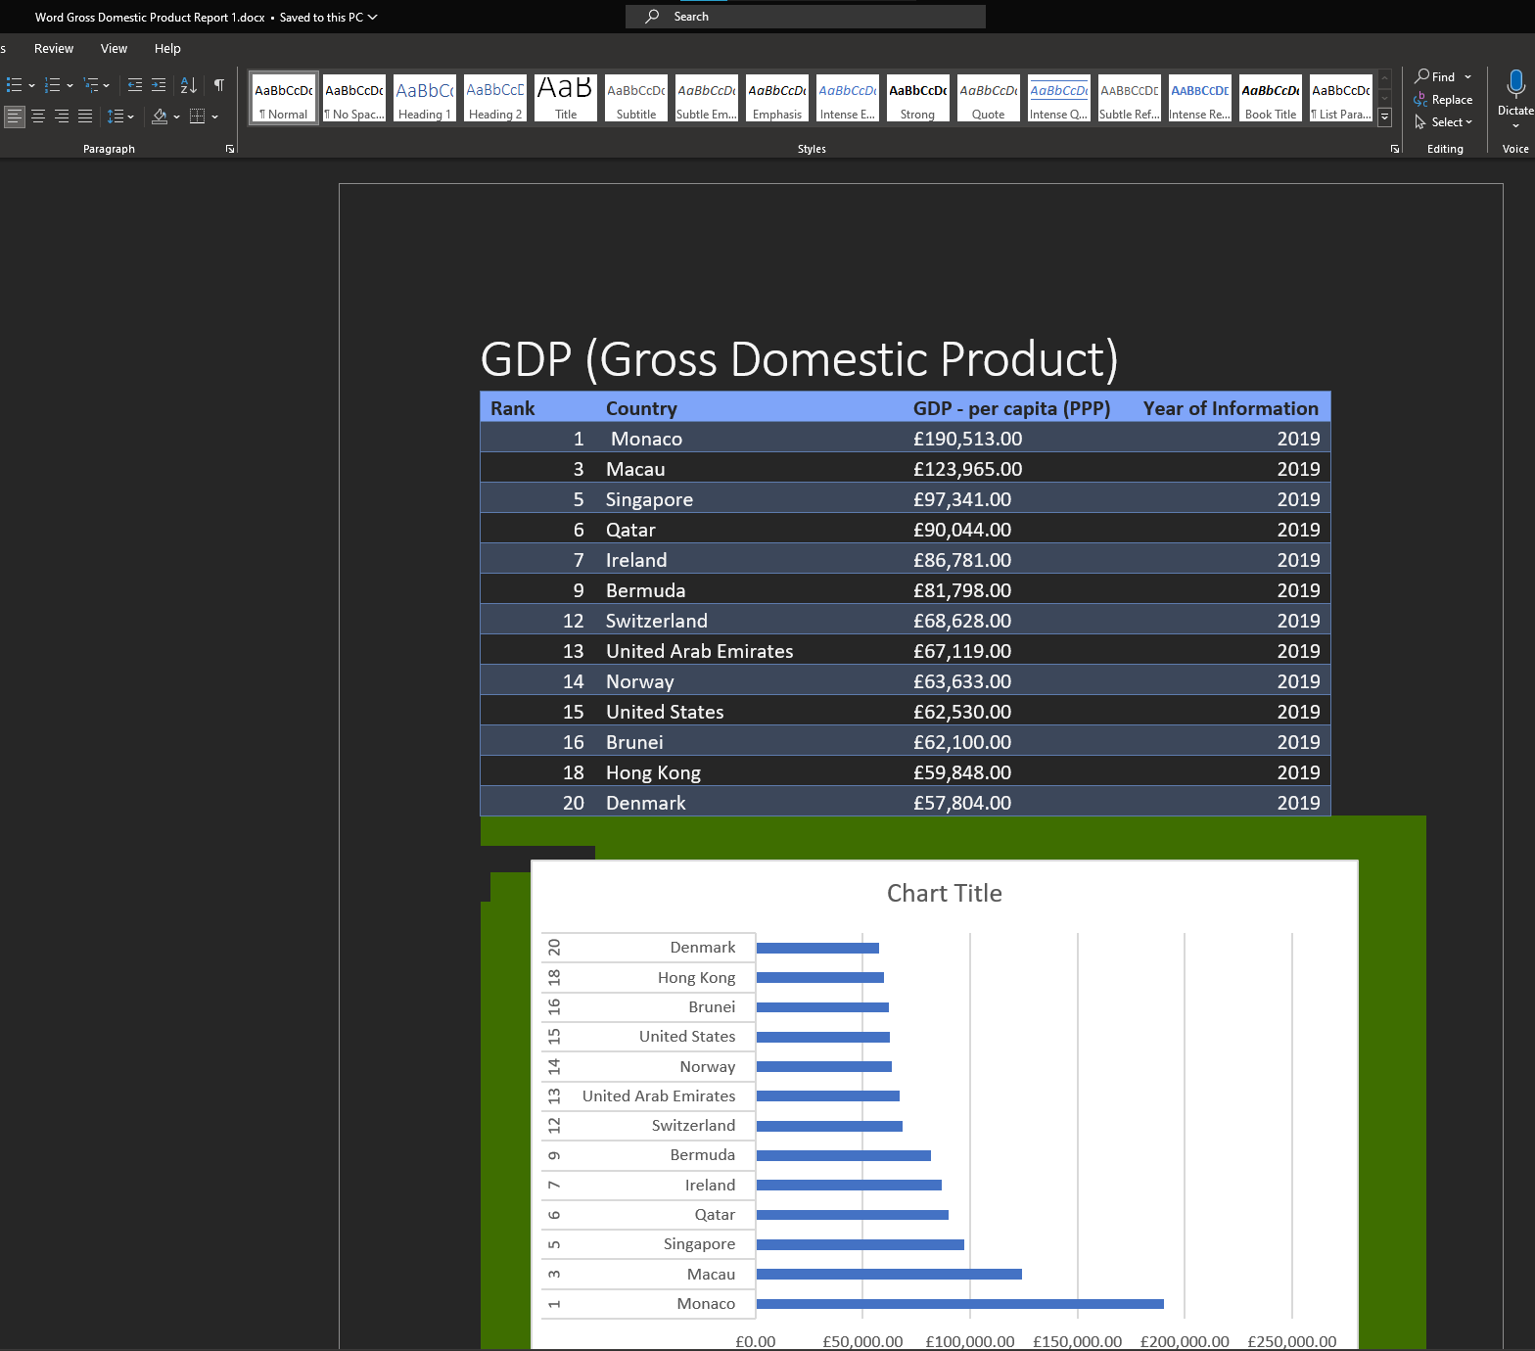

## 14 to 17 – Adding Header and Footer to Table

To proceed, a header and footer will be added to the GDP table. This will be done by selecting Views – Workbook Views – Page Layout from the ribbon bar:

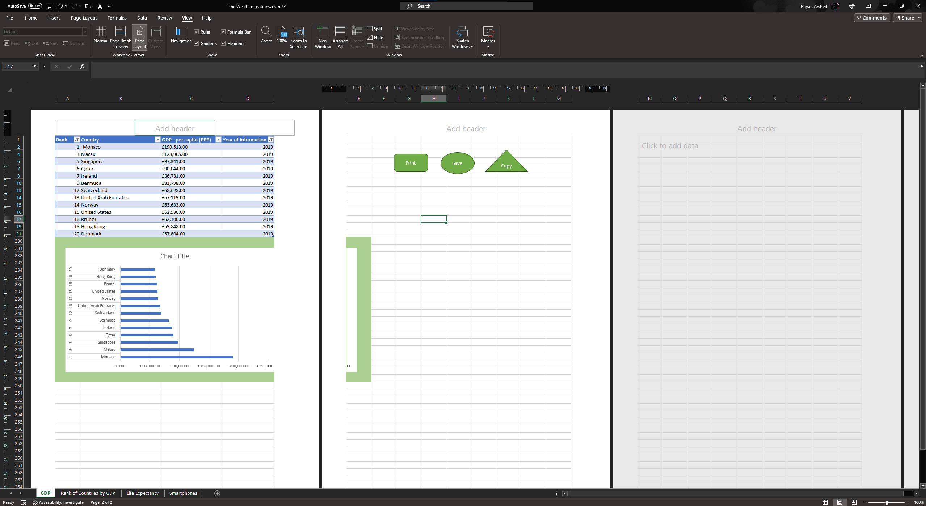

In this page selection menu, there are 3 possible values to add to the header for the spreadsheet:

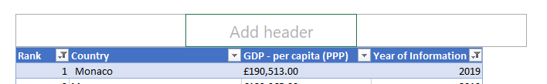

And in here, the name of the author can be added:

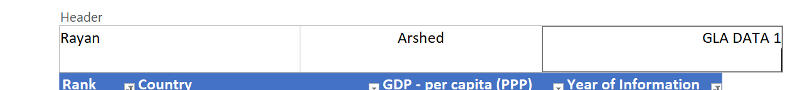

And in the footer, further relevant information can be added:

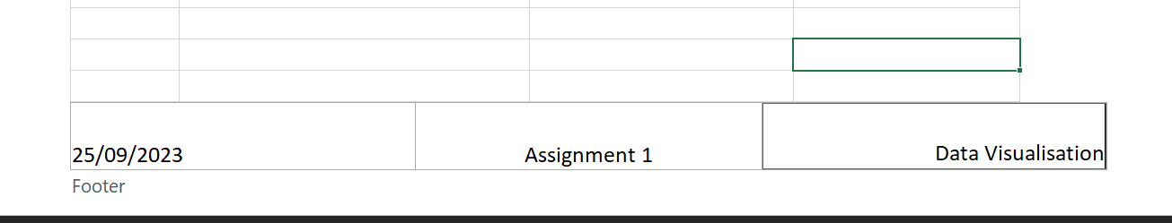

After doing this, the view can be returned to normal.

## 18 to 19 – Finalising and Saving

Now that layout changes have been done, the password can be re-enabled on the document, and to confirm the padlock is highlighted meaning the workbook is protected once again:

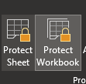

With this done, all due diligence to protect the file has been completed, and the workbook can be safely saved.

Finally, with the workbook saved, the word document containing the copy result can be saved too, and closed:



# Third Task – Working with Tableau

## 1 – Importing Data

Moving over to Tableau, it is time to create the visualisations and dashboard to represent the data from the spreadsheet. To begin with, upon opening Tableau, connect to a Microsoft Excel file was selected, and the workbook was chosen. Once this is done, the first few worksheets can be dragged into the open window.

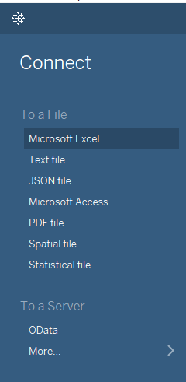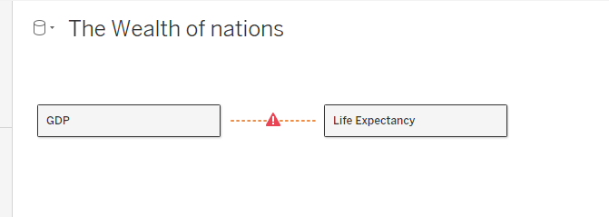

## 2 – Setting Relationships between Worksheets

As seen above, the relationships between the worksheets have not been established yet. Based off the data set, there is a Country Name column in each worksheet. As this acts as a Primary Key that uniquely identifies every record, the relationships between tables can be established using the Country Name field to correctly link the tables together. Linking this field across tables will look like so:

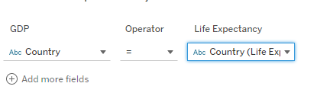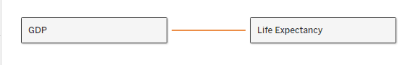

With this done, the relationship between the GDP and Life Expectancy tables has been mended, allowing for the Smartphones table to be added and the relationship established between all three:

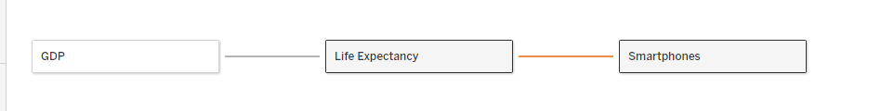

With the relationships set, the next process in the Tableau workflow is to check data types.

## 3 – Check Data Types

Checking through the default selected data types for each field, Tableau has done a good job at identifying the correct data types for each column. Across the three tables, Rank has been set as a whole number which works well for sorting later. Country has been set as Geographic, which is ideal and allows for using map diagrams when analysing the data. Life Expectancy, Smartphone Numbers, and GDP have all been set to Decimal Numbers, which is ideal as these columns provide data that is accurate to a decimal degree, so no changes are needed there. Finally, Date of Information is provided as a whole number, which while contradictory to the value being a date, does not need to be changed, as the dates provided are whole number years, meaning that integer format will work just as well for these values, so no changes are needed. As such, the data format will be as seen below:

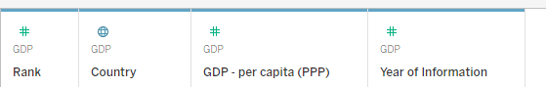

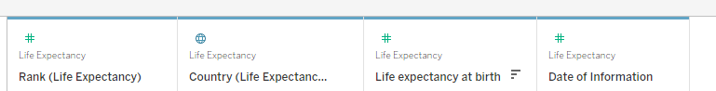

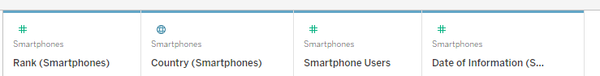

## 4 + 5 – Building Charts

With the data formatting sorted, it is now time to build some basic charts and KPIs to be used later in the dashboard and story. Working from the client’s request, they are only interested in the top 20 highest ranking countries. As such, no figures will be made for any lowest ranking countries.

A solid start would be to create KPIs (Key Performance Indicators) for each table, to show which country is the lead in each category.

By adding the values for Life Expectancy, GDP, and Smartphone Owners into a table, and filtering by Rank to achieve the highest, it is possible to get KPIs for each 3 indicators:

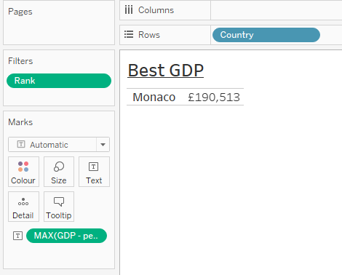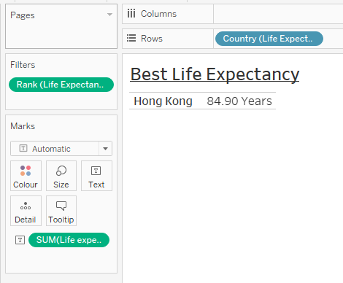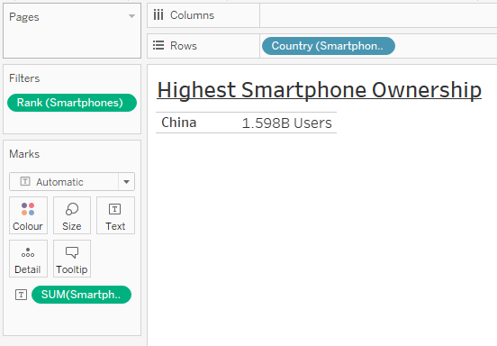

These figures will be usable in the dashboard as KPIs.

Considering that the dataset provided contained countries and their respective values, the next logical chart to build would be map charts for each figure to map out the performance across the world. By dragging each key value and the countries into the window, a map can be made for the world to map these figures. This creates world maps that can then be set to maps to highlight each individual country and colour code their values. Having experimented with a GDP map that has been filtered to the top 20 countries, the range of GDP in the higher end is extremely diverse, so a colour coded map may not be ideal for this scenario, as seen below:

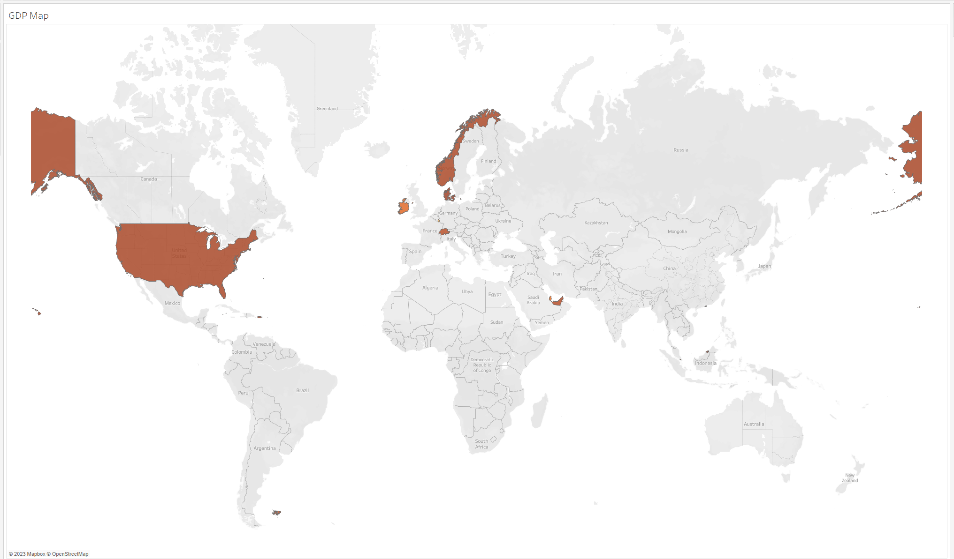

Monaco, the country with the highest GDP, is extremely small relative to the world, barely visible and fitting within France as seen below:

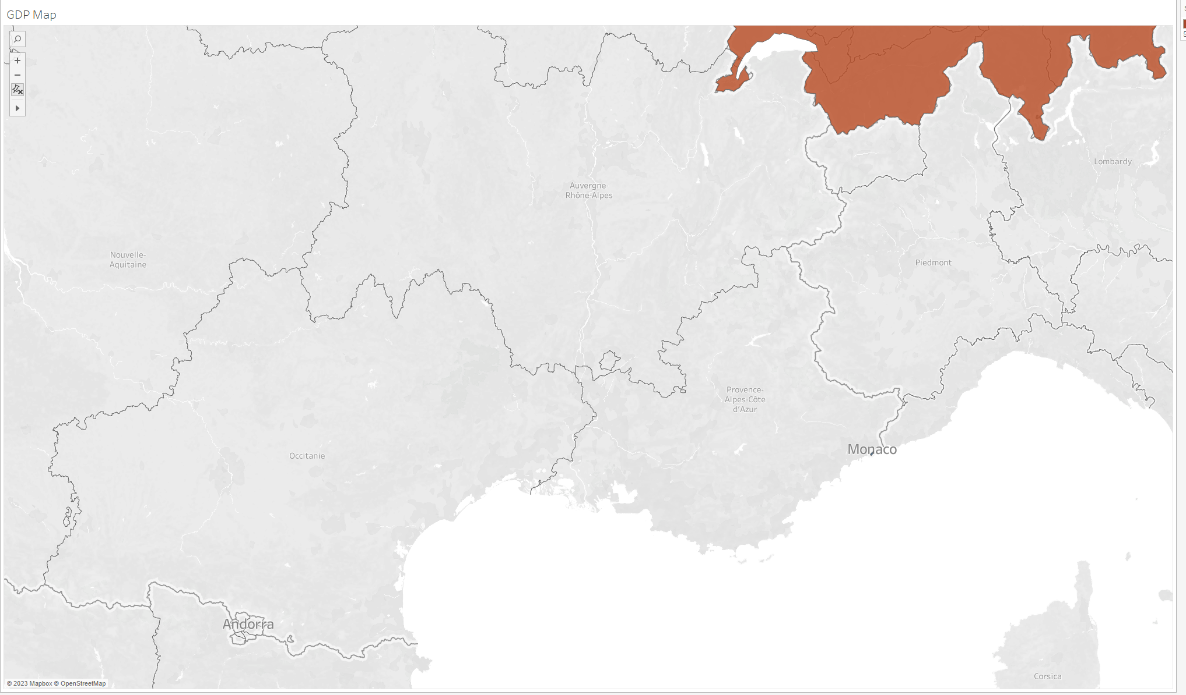

As this format does not work well for GDP due to its variety in results, a Bubble Chart can be used instead to disregard Geographic position but represent the top 20 countries as seen below:

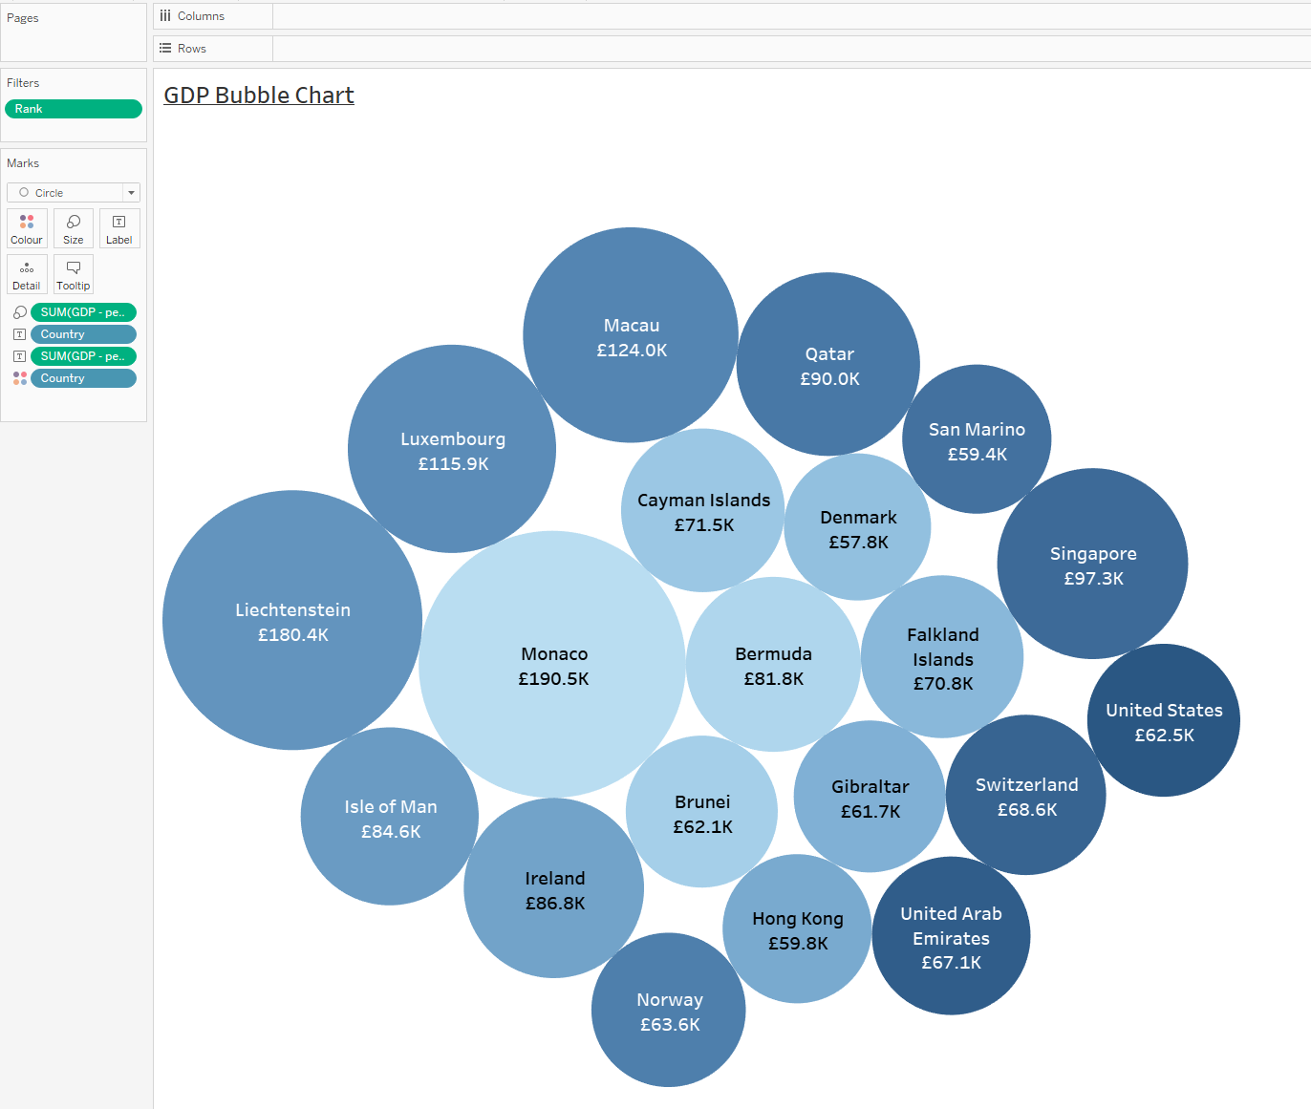

In consideration to the client’s colour-blindness, the colour palettes that will be in usage will either be distinguishable from each other, such as blue-orange, or feature gradients in a single colour to be distinguishable, as with the above blue-teal colour palette.

For Life Expectancy and Smartphone Ownership, a Map chart works well as there is a varied spread across the world, with very few outliers unlike GDP, so these factors can be mapped on a chart as seen below:

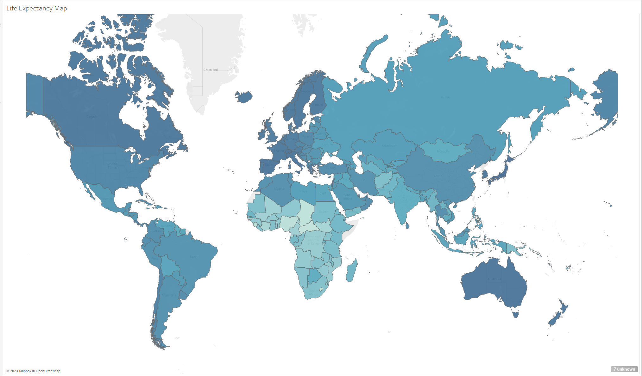

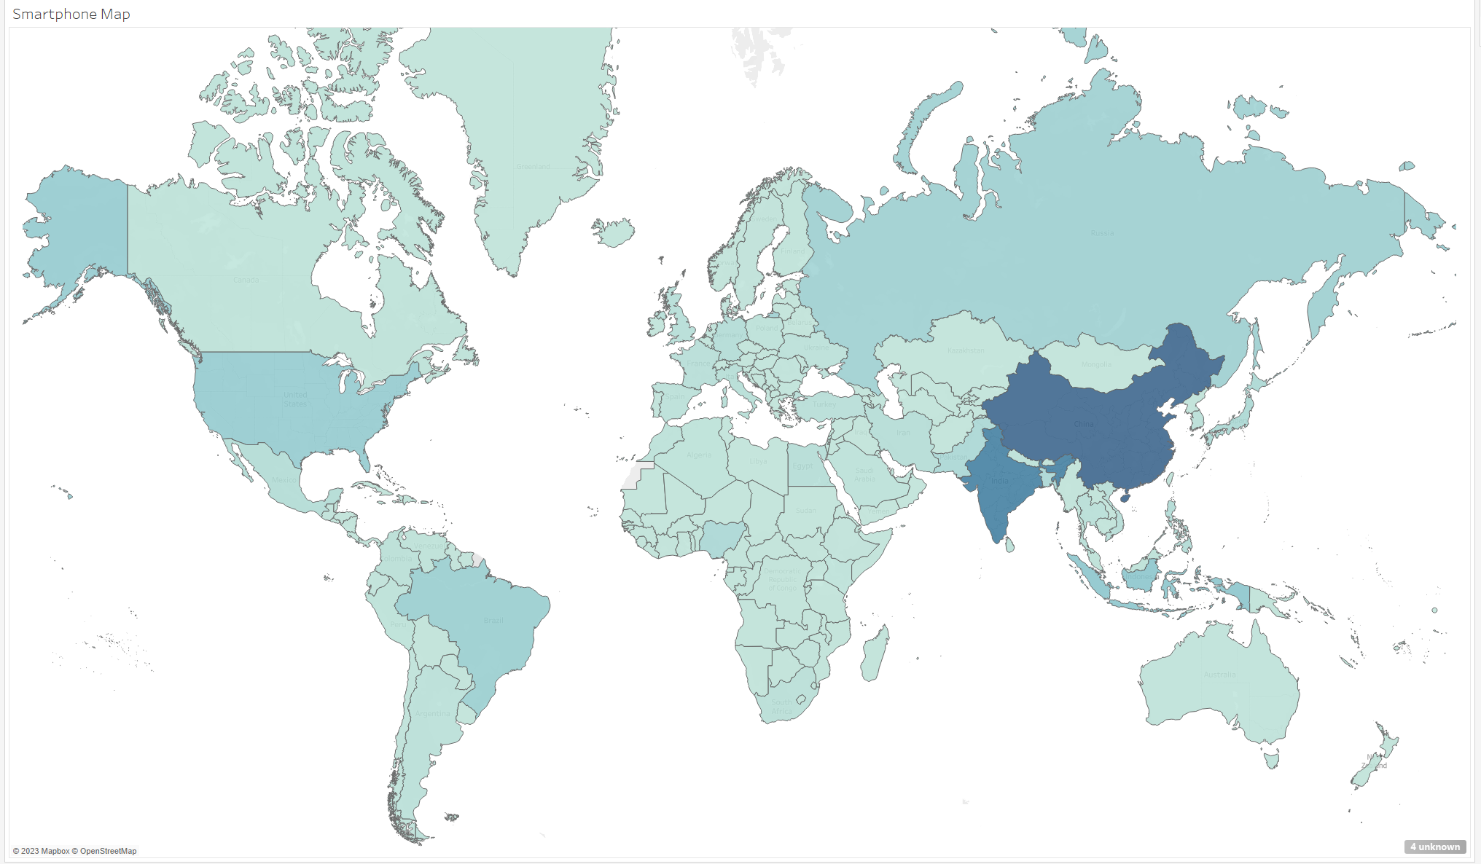

As there are unknown values in these maps, it will be worth going through and correcting what is possible. For example, on the Smartphone map, these are the unknown locations:

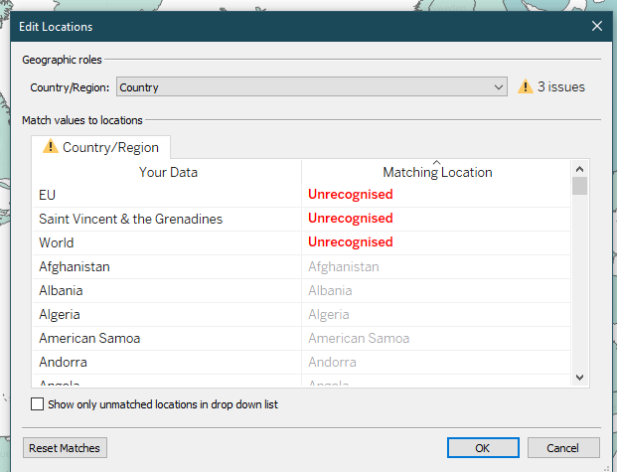

EU and World are too general, so they will not be assigned a location. However, Saint Vincent and the Grenadines is an actual location, that in Tableau’s database drops “the” from the name, so that can be altered, while the other two values are removed.

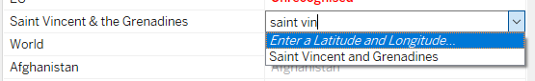

The other two values are filtered out, and result in no unmatched errors. The same is done to the Life Expectancy map, which features general regional descriptors as locations, which can all be filtered out from the map.

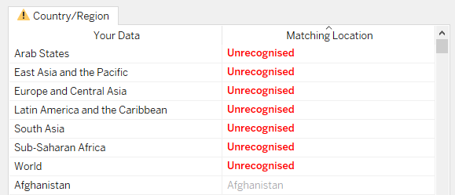

It would be possible to filter out the map to show only the top 20 countries for each statistic, however personally I believe showing the distribution of values across the world looks better as a visual. However, when filtered, this is how the map looks:

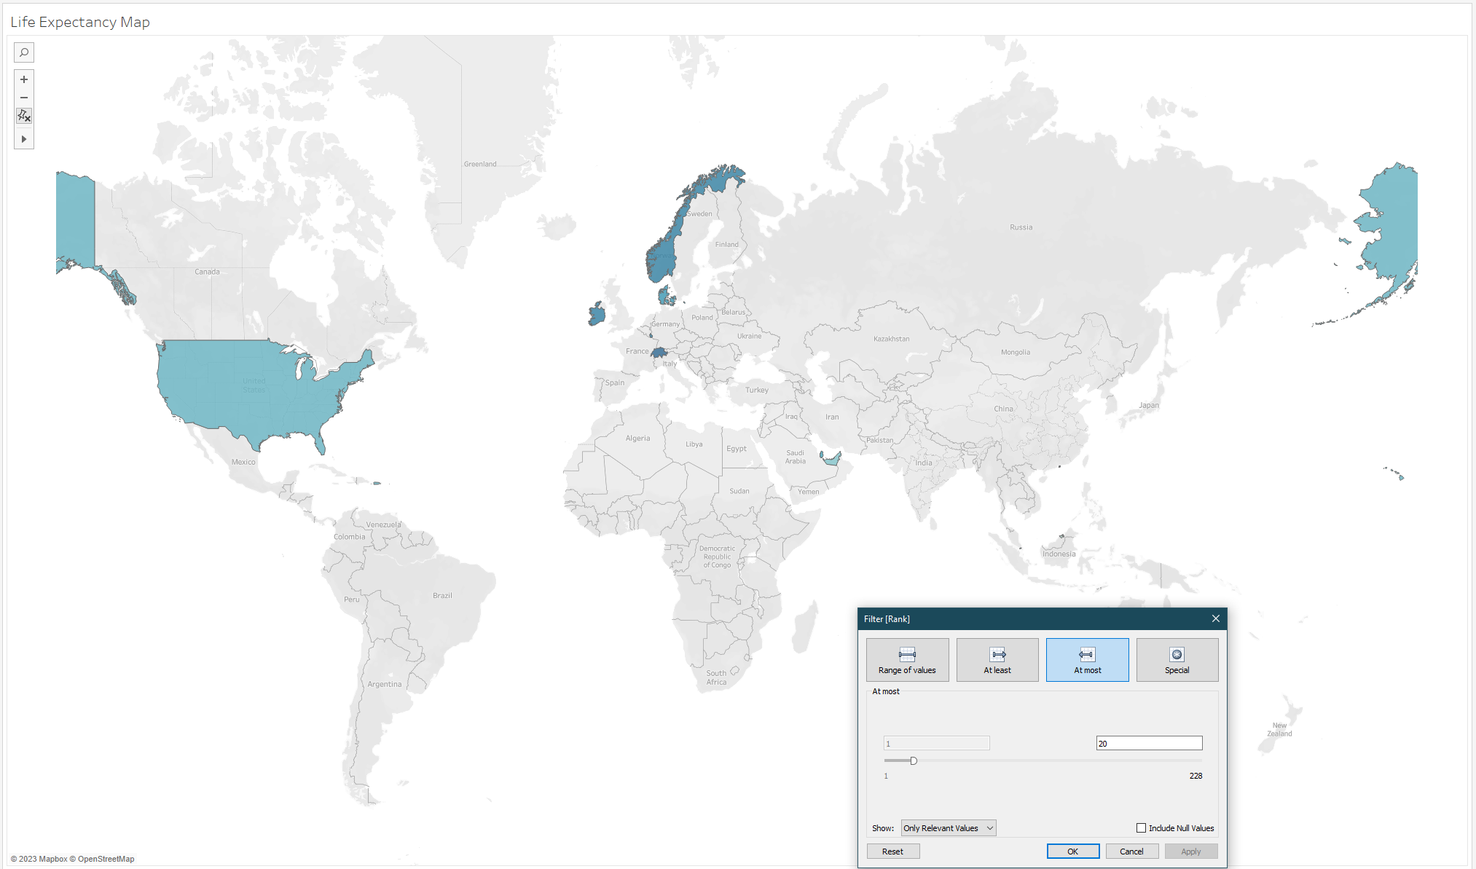

As such, the maps will be kept unfiltered to provide a visual representation. Keeping in line with the colour-blind guidance, Orange and Blue seem to be a good pair of contrasting colours that can help with visualising the differences between countries, so an Orange-Blue gradient will be used on these maps for clarity. The colour disparity was still high, so a modified midpoint to the gradient has been selected while using the full gradient, aiding in understanding, and allowing comparisons of countries on the lower end of the scale:

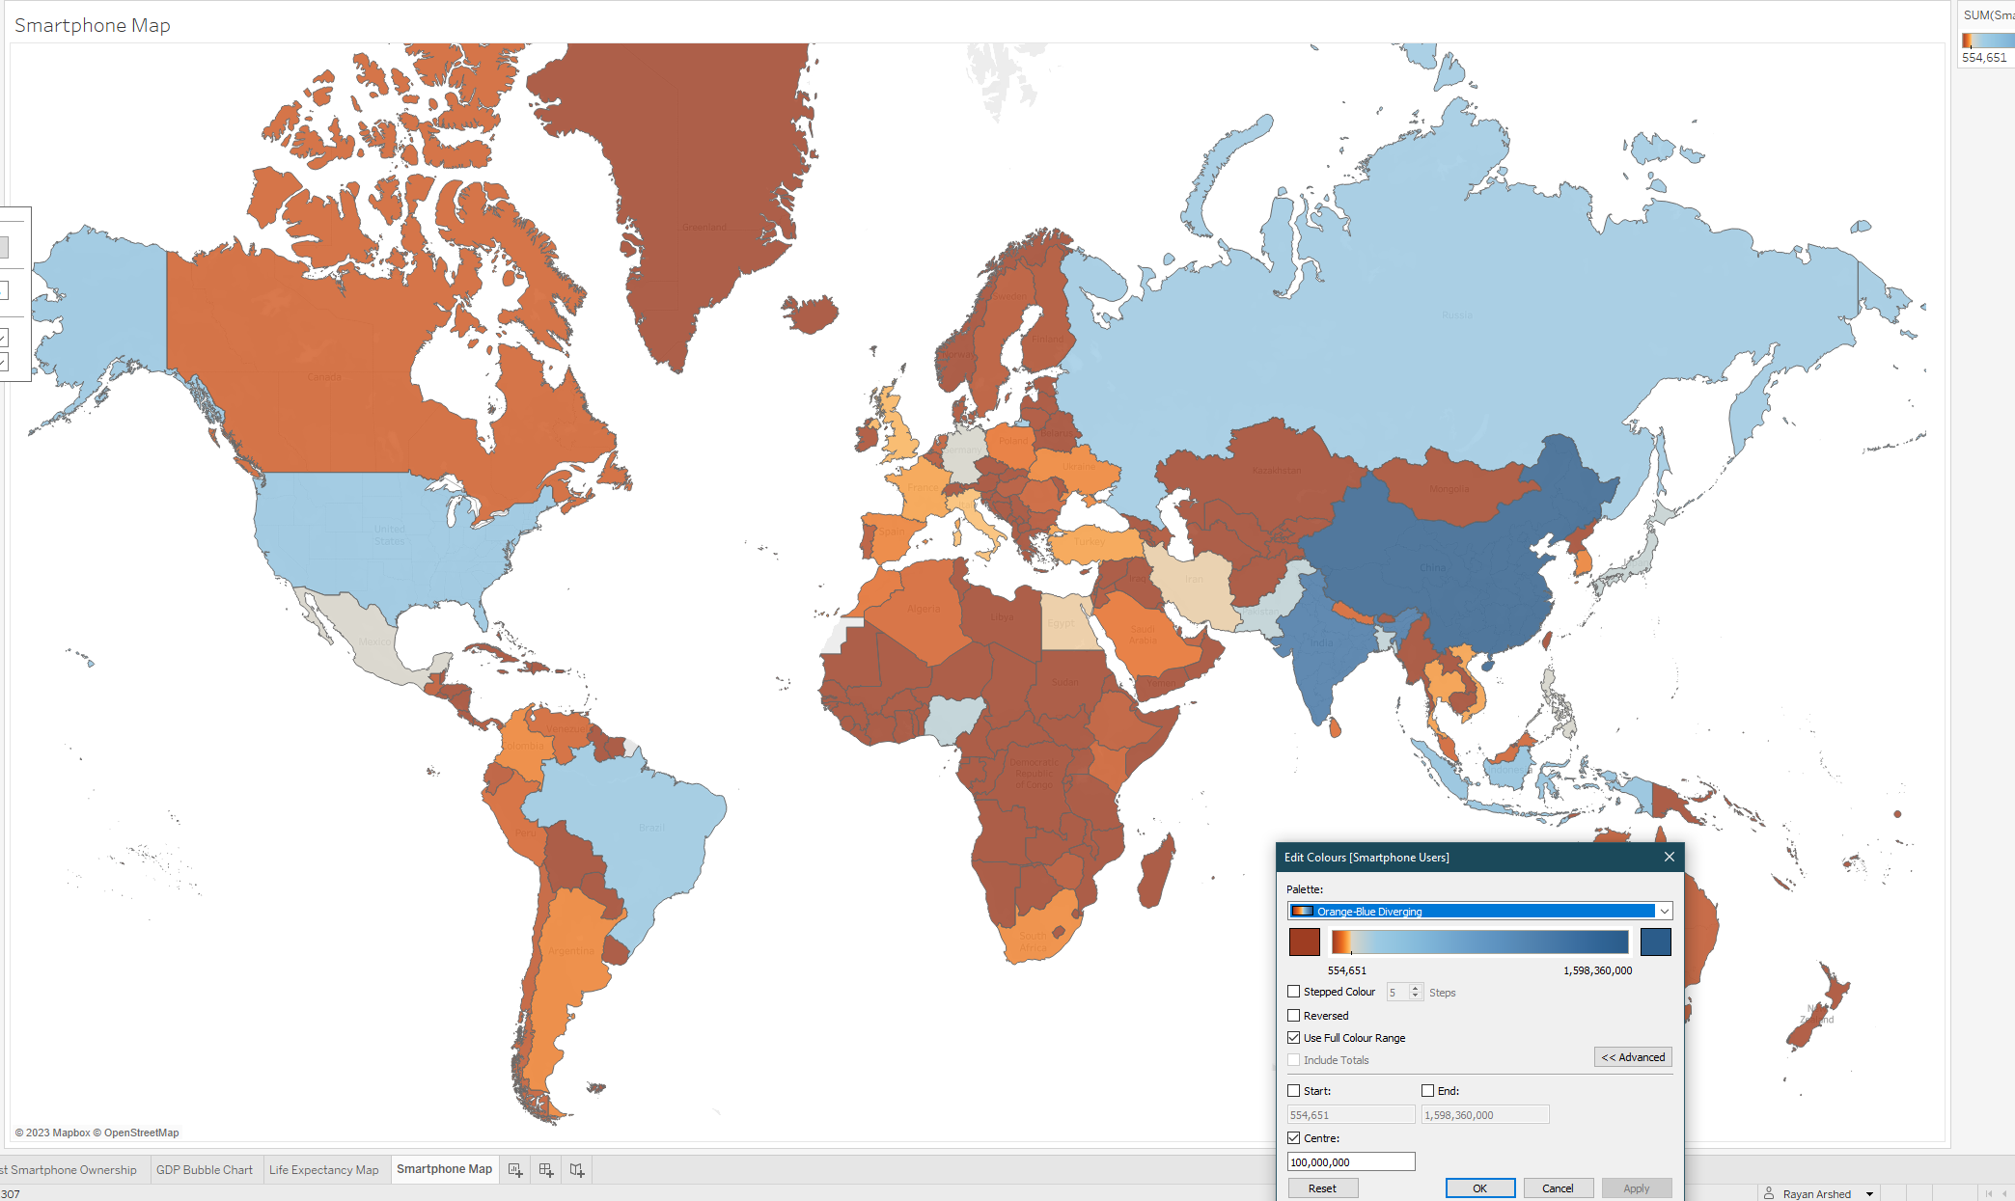

While this looks improved, it still is not perfect. To make it fit better, the midpoint could be set to the average population of a country, which when researching, appears to be 40.31 Million according to the following link: (<https://www.theglobaleconomy.com/rankings/population_size/#:~:text=Population%20size%2C%20in%20millions%2C%202022,196%20countries%20was%2040.31%20million>). When this value is used, a more colourful graph is produced, considering smaller countries such as European based countries, who due to having smaller populations, will also have less smartphones overall, and opens comparisons to countries in Asia, Africa, and South America:

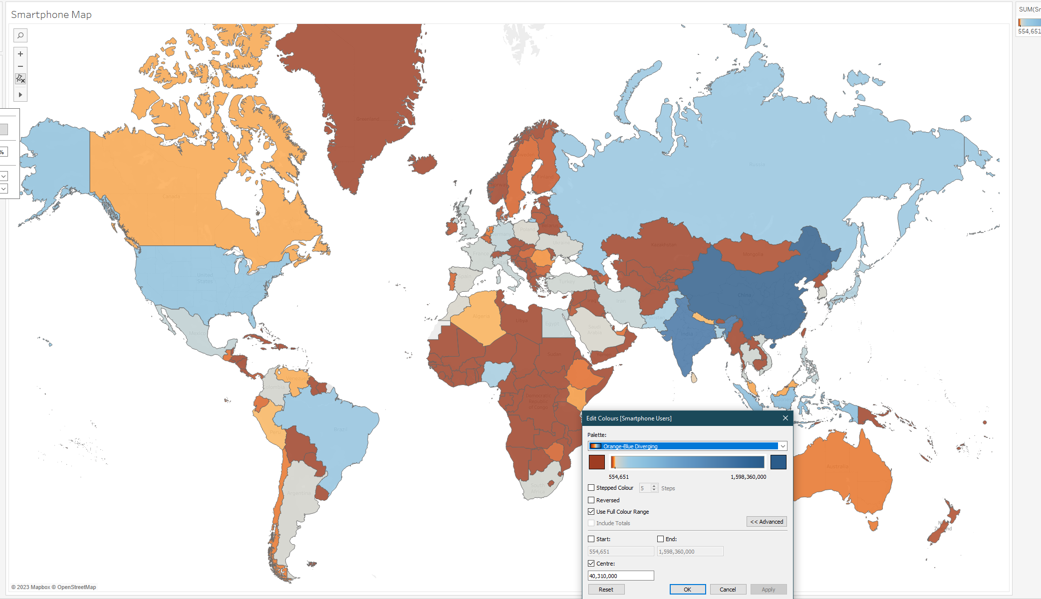

The chart for Life Expectancy across the globe meanwhile is much more consistent and narrow in potential values, which means no specific midpoint needs to be set for viable results as seen below:

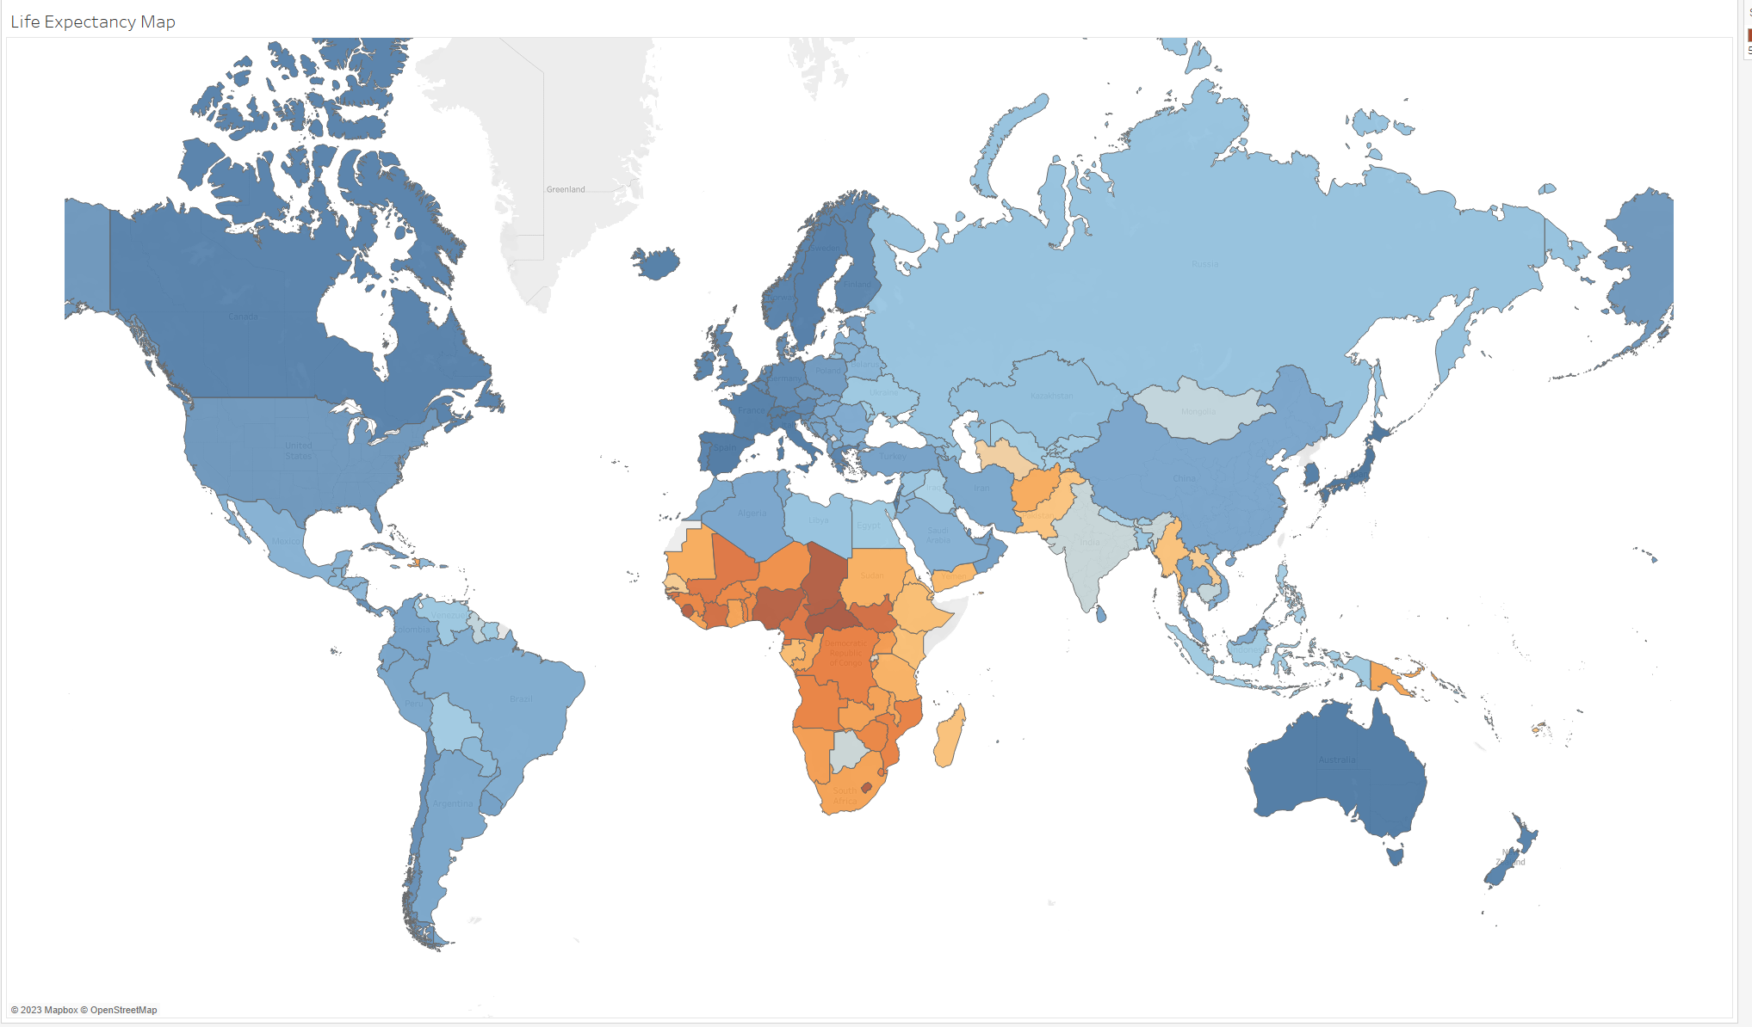

A quick double check shows that the map above has an error in it, the value for Country used for the map was taken from the Life Expectancy table, not the Smartphone table, leading to blanks when hovering over the darker areas for example in Africa. This has been corrected as shown below:

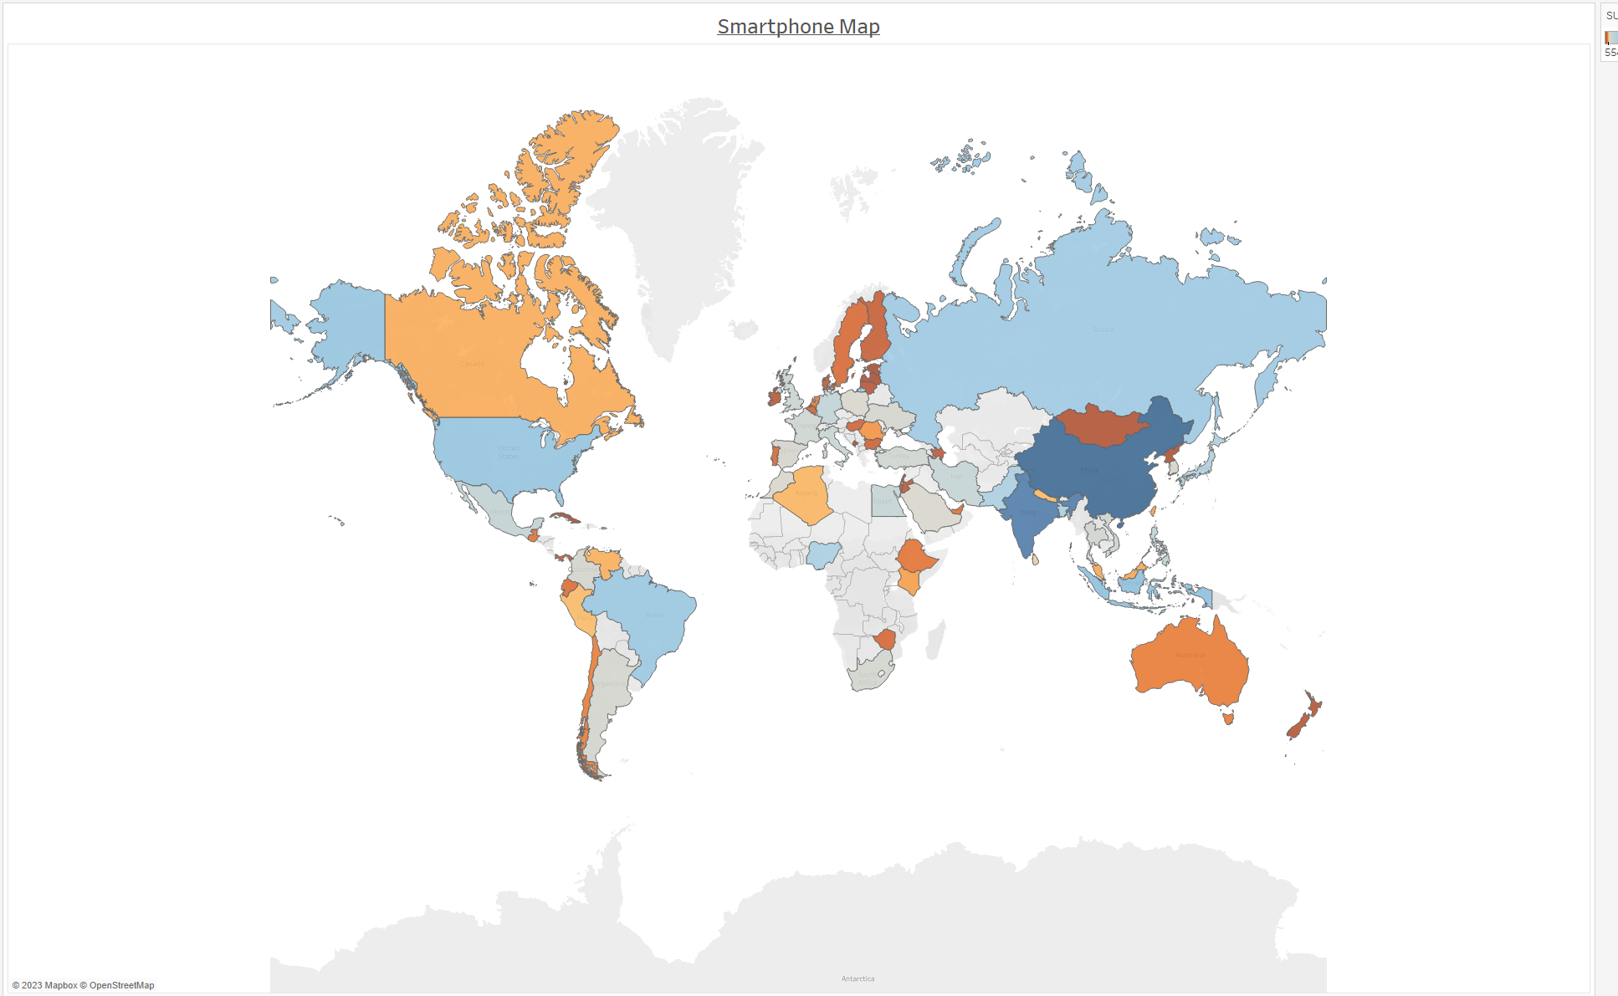

Ideally, the map for smartphones would work better if the statistic were smartphones / population, as that would give a smartphone per person metric that could be mapped better, however the graph available now still shows relevant information so it will be kept.

With these distribution maps now complete alongside the KPIs, next to be created as a chart will be bar charts for the performance values, which will allow comparisons between these countries that rank in the top 20 in each metric. Dragging the values over reveals a graph that looks like so:

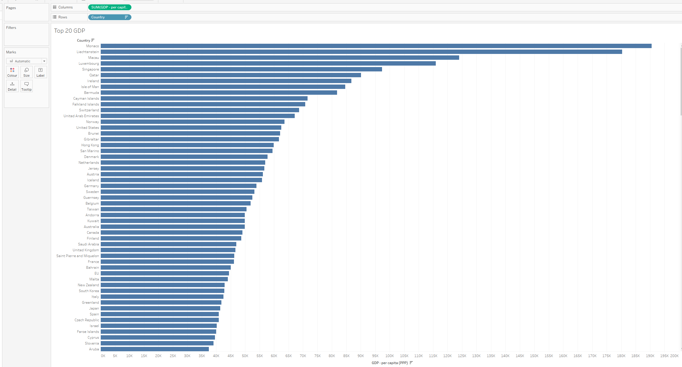

This will be filtered down to the top 20 values, as seen below:

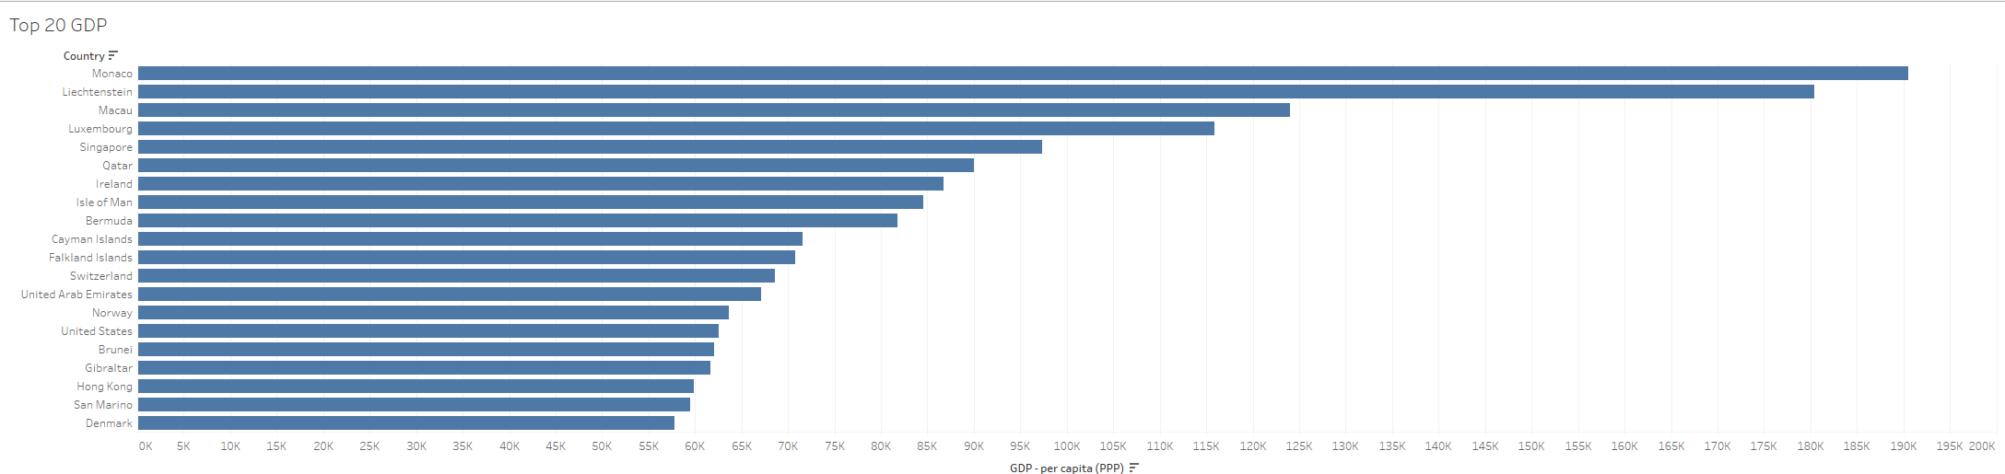

And when formatted correctly and tidied up, the result is shown below:

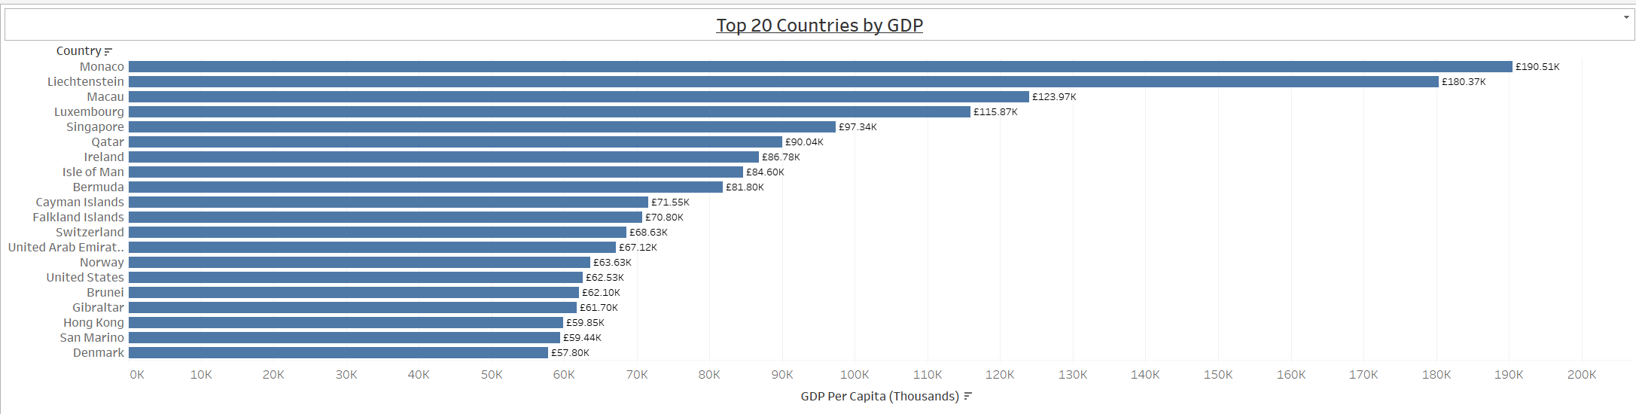

The same treatment has been applied to the other graphs for the key figures; the units have been shortened for ease of reading, and the titles of each graph adjusted for clarity.

The final figure to be created will be another visualization of Smartphone ownership. Similar to the GDP data, smartphone ownership varies greatly even within the top 20, so it can be assumed that a figure visualising these differences will be pleasing to see. While a Pie chart could be considered, there are too many values (20) to create a legible pie chart, therefore a Tree map has been chosen for this visualization, as seen below:

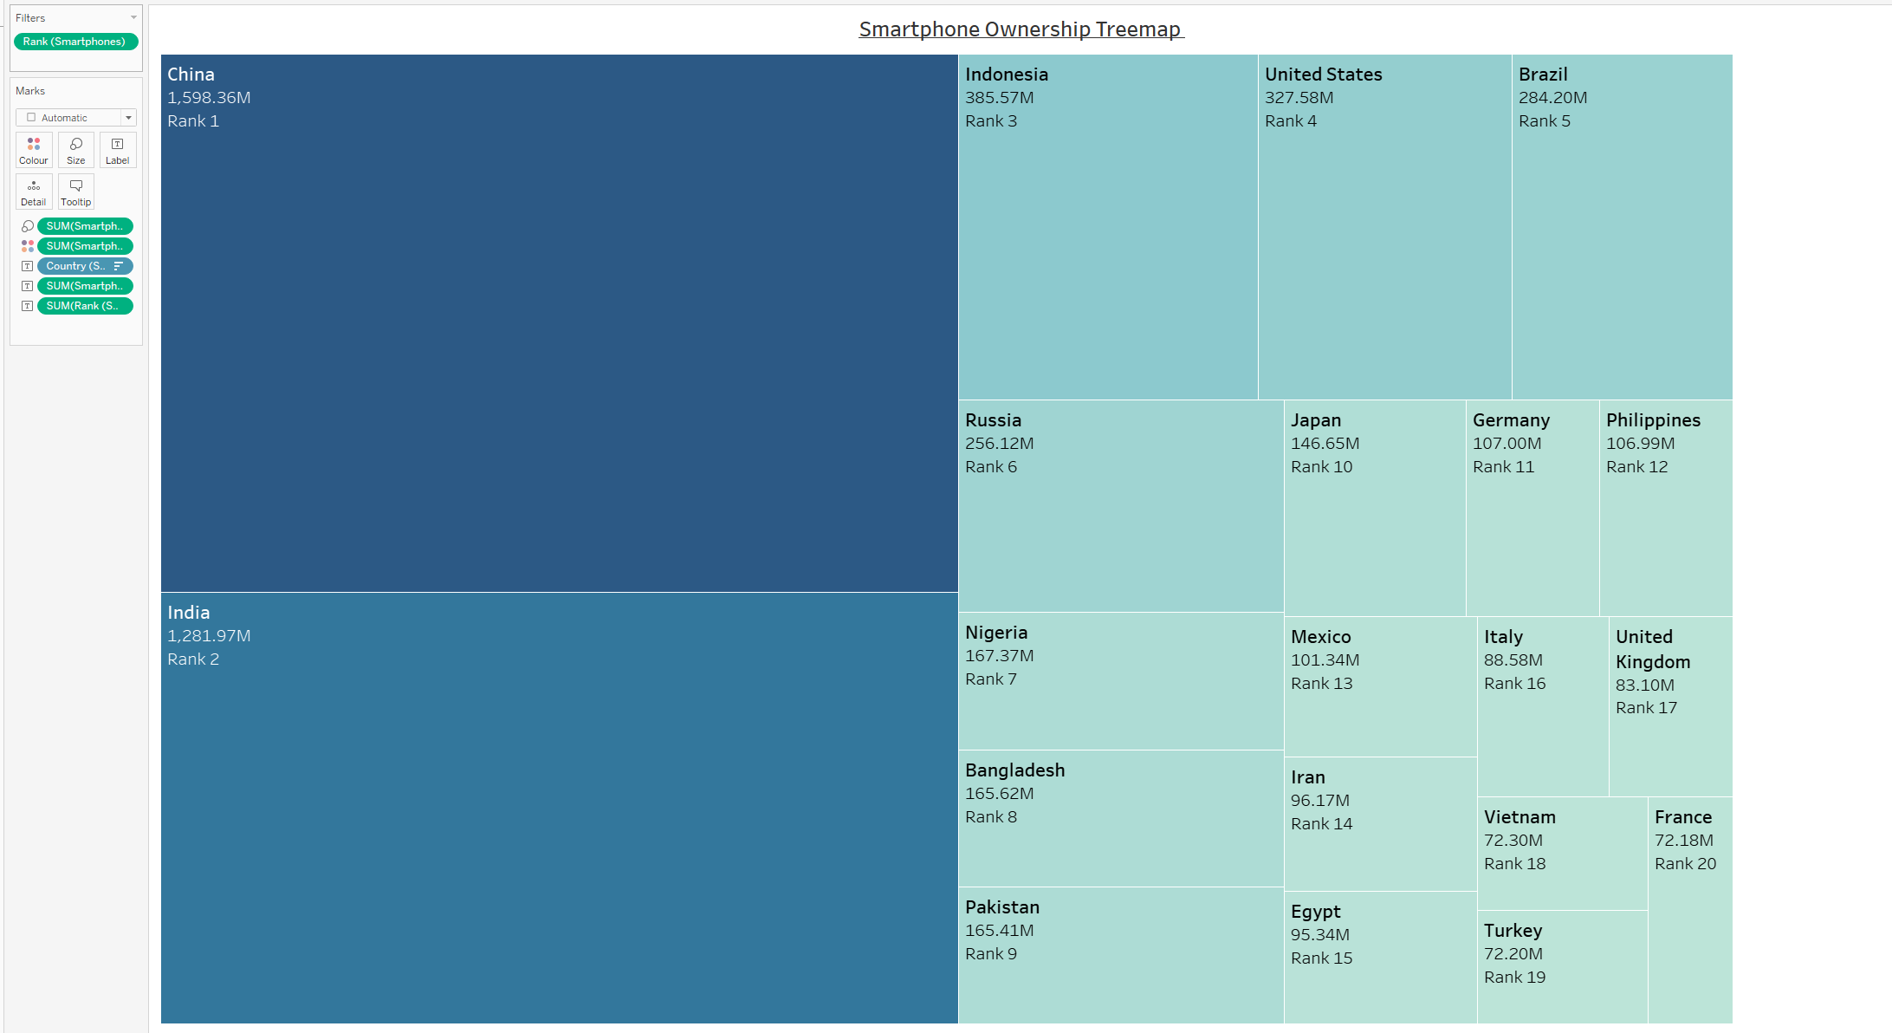

This has been created similar to the previous bubble chart, and labelling for the rank and the total values has been added to aid in understanding the meaning of the sizes in the chart.

With the basic figures so far completed, a simple touch-up can be applied to the worksheets to add a touch of colour and to make things overall look more aesthetically pleasing. Continuing with the blue-orange colour theme, the backgrounds of all worksheets have been made a soft cream orange, to add vibrancy to the page, while still being aesthetically pleasing to people with any variance in colour-blindness severity. Worksheets will now look like the one below, before entering my dashboards:

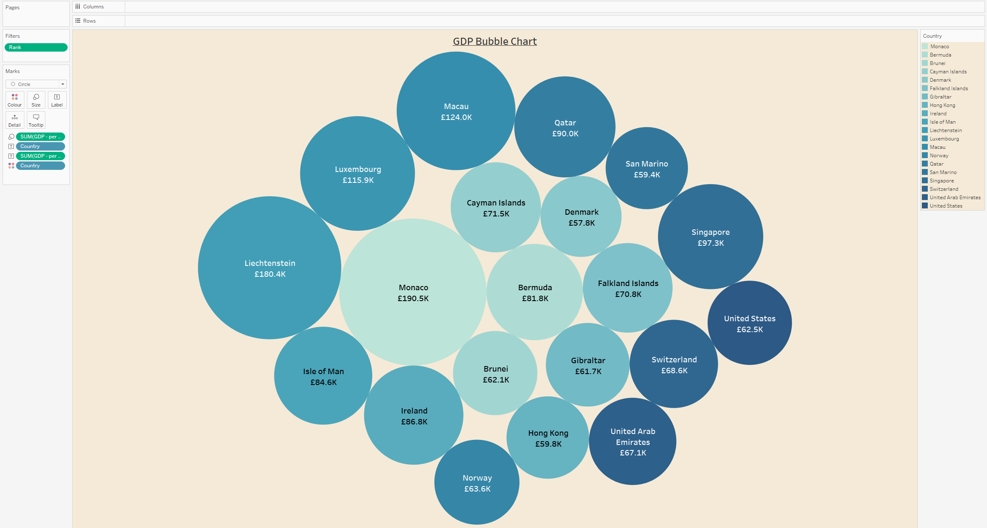

With a general colour scheme and figures completed, work on the dashboard in earnest can now begin.

## 6 – Creating The Dashboard

To initially start and plan with the figures available, I have determined that creating a story comprising of three dashboards will be ideal. As there are 3 KPIs total, a dashboard can be dedicated to each aspect of the data, with a story used to join the dashboards together and to include interactivity.

To begin, each dashboard has been created, and the size of each has been set to Automatic to allow easier customization and resizing as seen below:

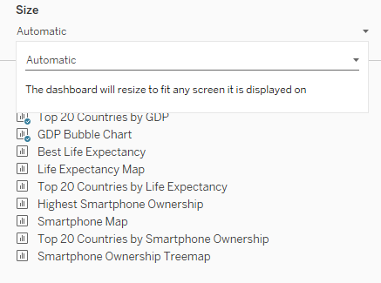

With that done, the colour scheme has also been applied to each dashboard, and the story format has also been established, looking like so:

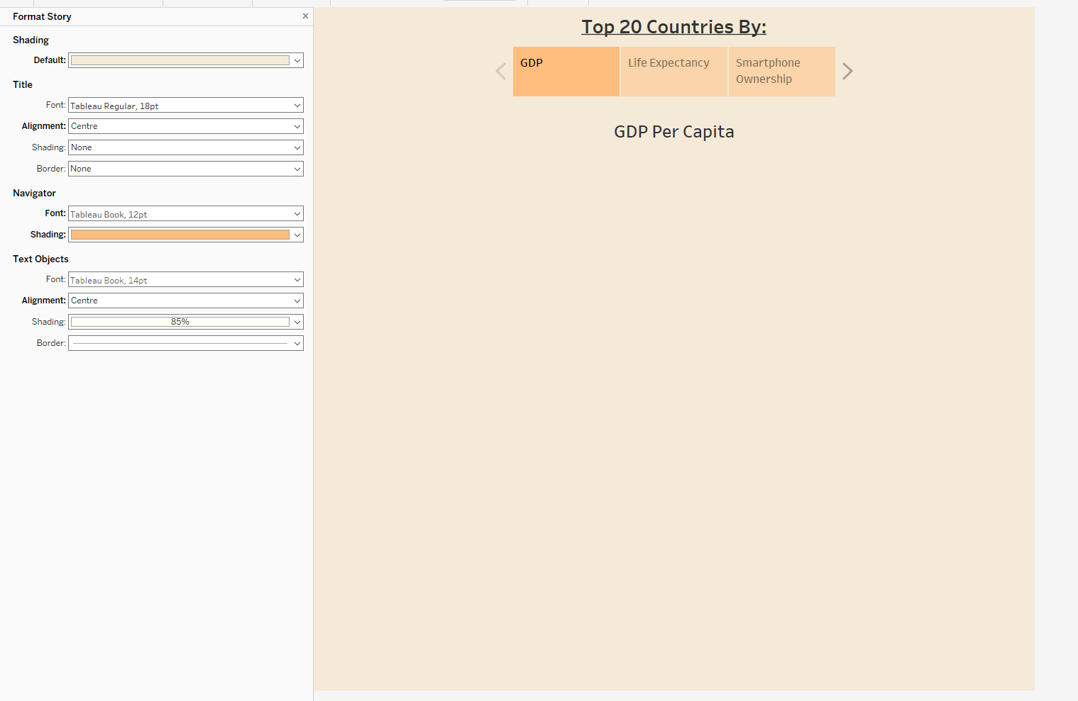

From here, each dashboard can now be customized and edited, starting with the GDP dashboard. As there are 3 figures for GDP, these will be added to the dashboard using the fixed container format so that the figures can be spaced out well allowing for clarity of reading. After some tweaking and experimenting with font sized and titles, the first dashboard is complete, for GDP, as seen below:

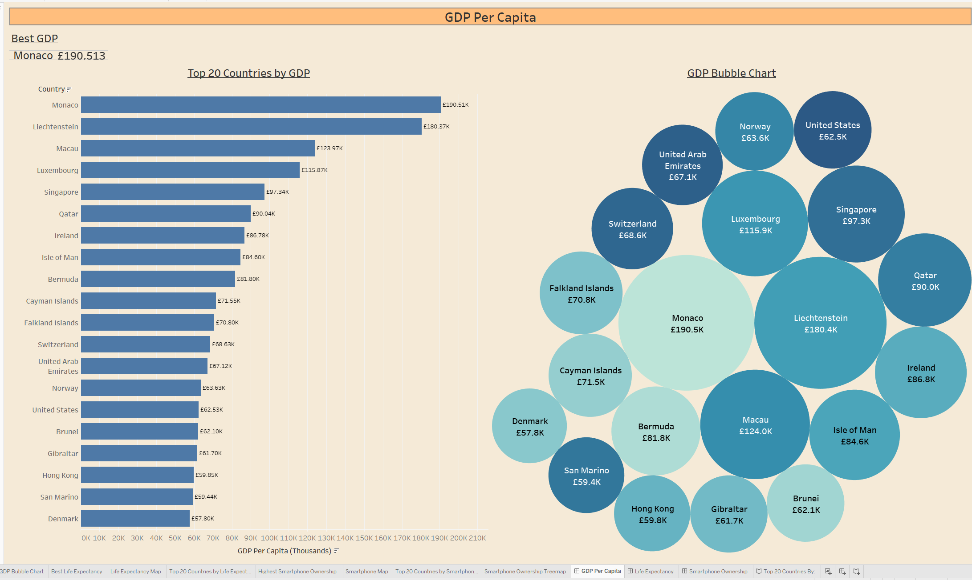

To ensure that the design is legible for colour-blind people, I used a website upon completing this dashboard to verify that my design meets the user’s criteria. This website is [https://pilestone.com/pages/color-blindness-simulator-1#](https://pilestone.com/pages/color-blindness-simulator-1) , which allows for colourblind filters to be applied to images. Checking all the filters, as no specific colour-blindness has been specified, my dashboard appears legible and should satisfy the criteria. For reference, here is how the dashboard appears with Green-Blind Deuteranopia:

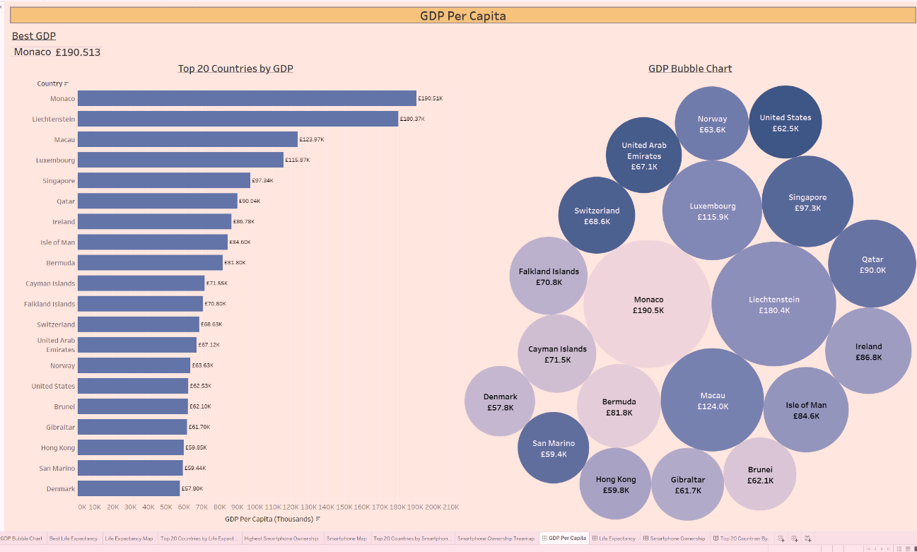

This result is promising and legible without negatively impacting colourblind users, therefore the criteria for accessible design should have been met. Satisfied with this result, these design specifications will be used to create the next two dashboards. The next two dashboards may be slightly more challenging to create, as they have more figures than GDP did, meaning that careful usage of space will be required.

The Life Expectancy dashboard has been completed, looking like so within the story:

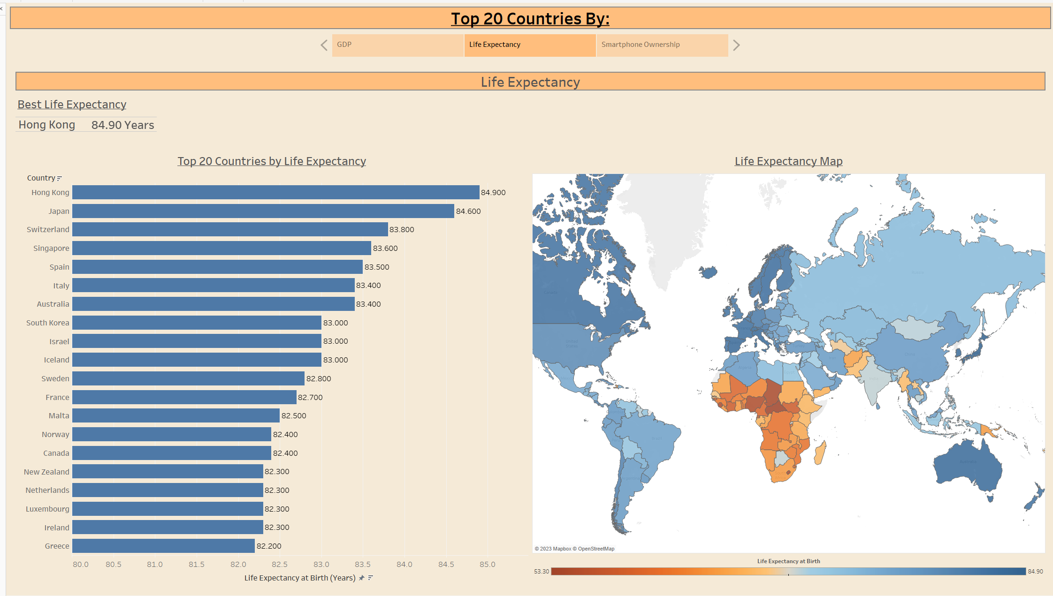

And when considering colour-blindness, this time Red-Blind Protanopia, the result looks like below:

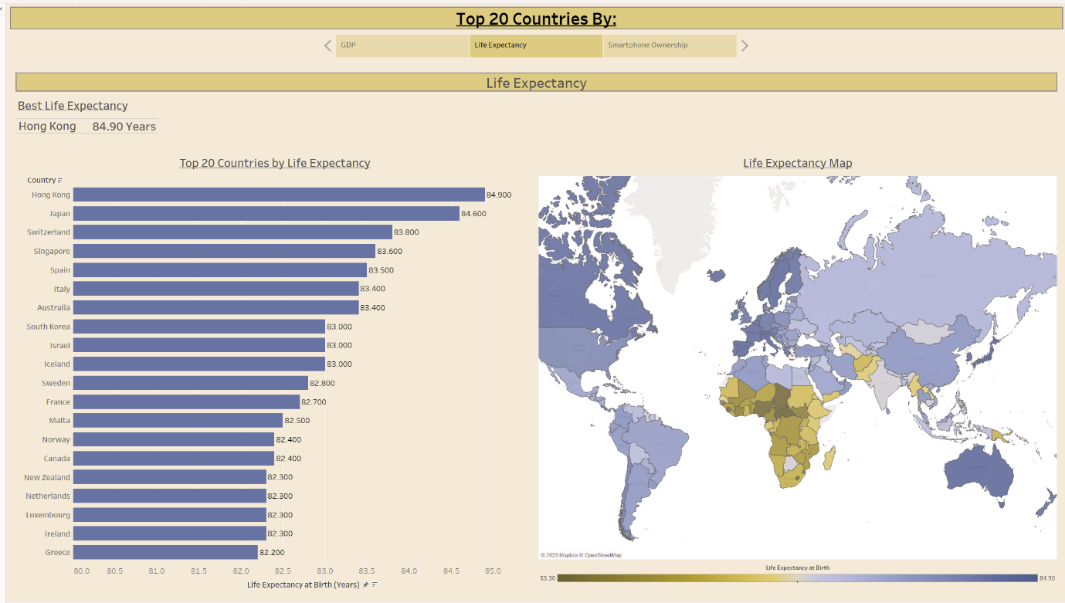

Again, the colour scheme used for these dashboards appears accessible and readable in a wide range of colourblind contexts, satisfying needs for the client. Finally, the last of the dashboards can be created, for Smartphones. This will be the most challenging of the three dashboards due to the number of figures available to create this dashboard. Considering the format the KPIs have been implemented previously as a single tile at the top of each page however, I decided that replacing the Smartphone KPI with the tree map diagram would be best, as it includes the KPI as its leading value, so my final dashboard within my story is as you can see below:

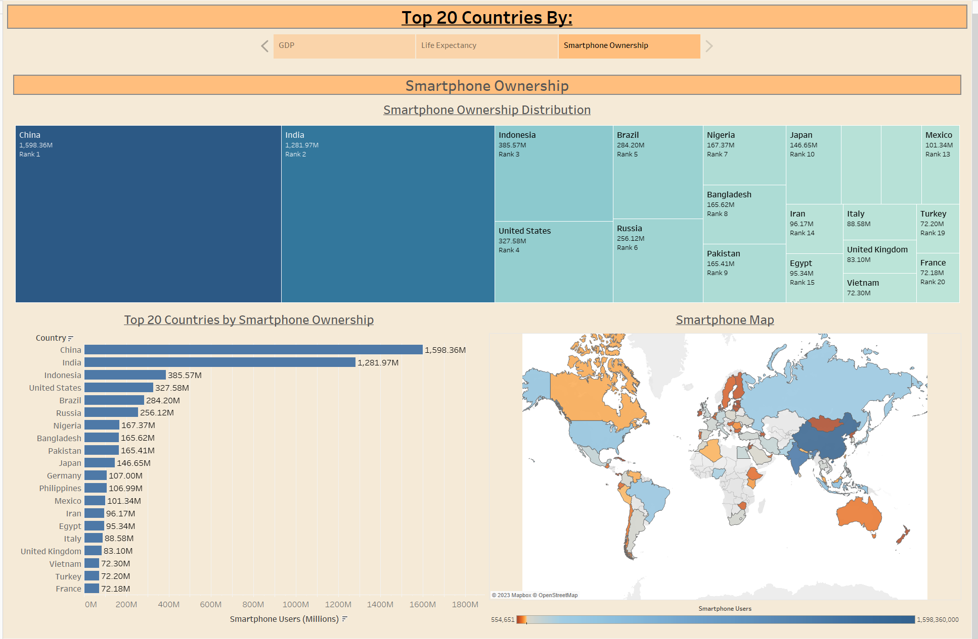

And once again, considering colour blindness, here is how it appears with Blue-Blind Tritanopia:

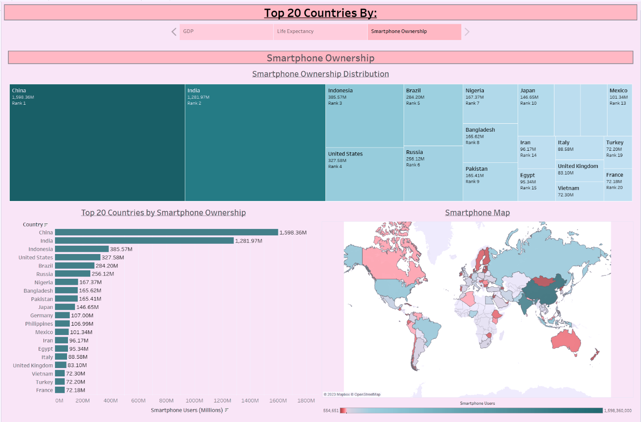

With all three dashboards completed, the Story has automatically updated with the three dashboards. After some font colour tweaking to add contextual sense to the headings in the Story (e.g. the heading is a darker text colour than the subheadings, being the dashboard names), the Story has been published to Tableau Public and can be viewed via the link below:

<https://public.tableau.com/shared/ZZWMPGMPX?:display_count=n&:origin=viz_share_link>

And for clarity’s sake, here is how the story appears on a 1080p monitor in full screen:

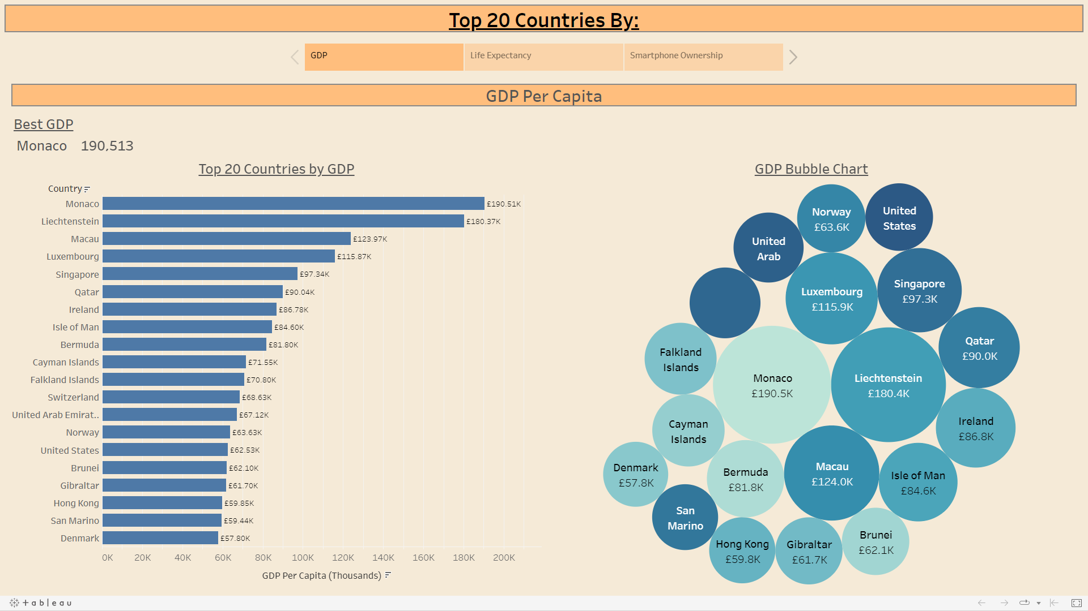

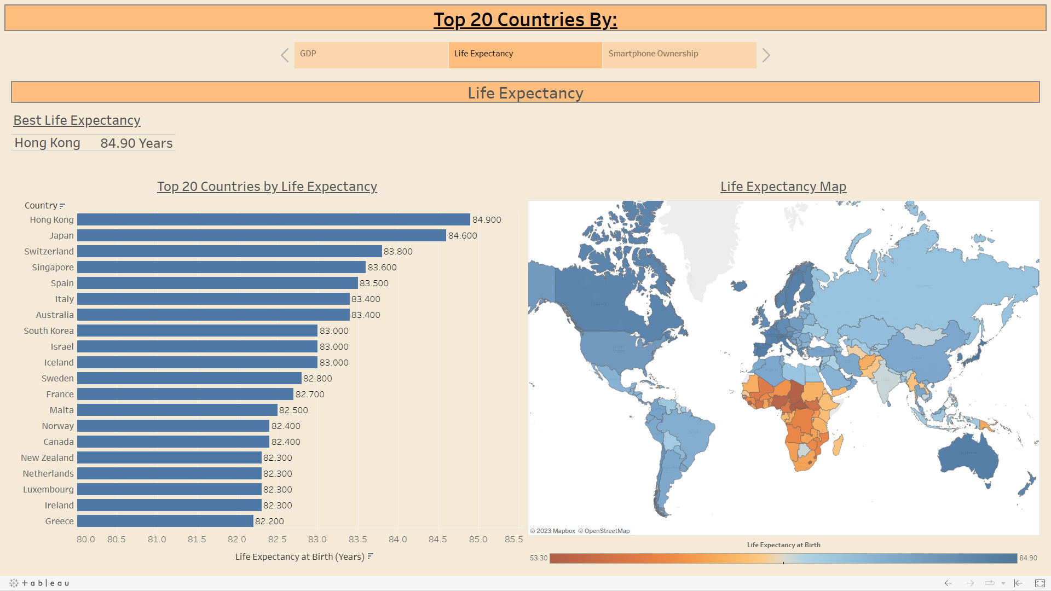

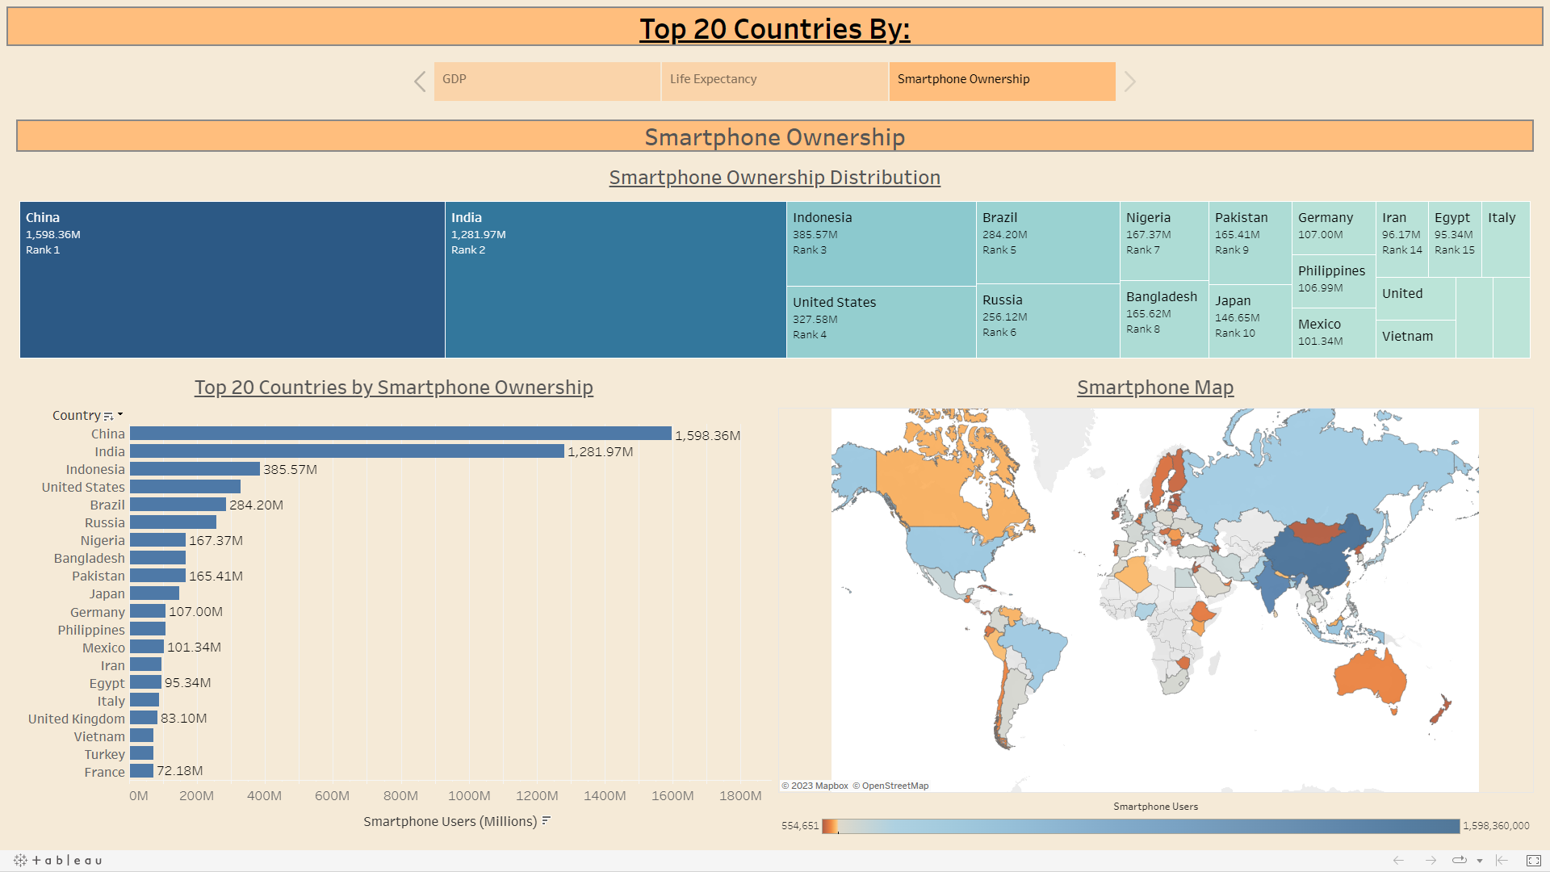

All the figures are interactive with the mouse, so any information missing from say the tree map, can be hovered over to reveal that information. Some of the information is cramped on a 1080p screen when not full sized, such as on the smartphone ownership screen, as seen below: 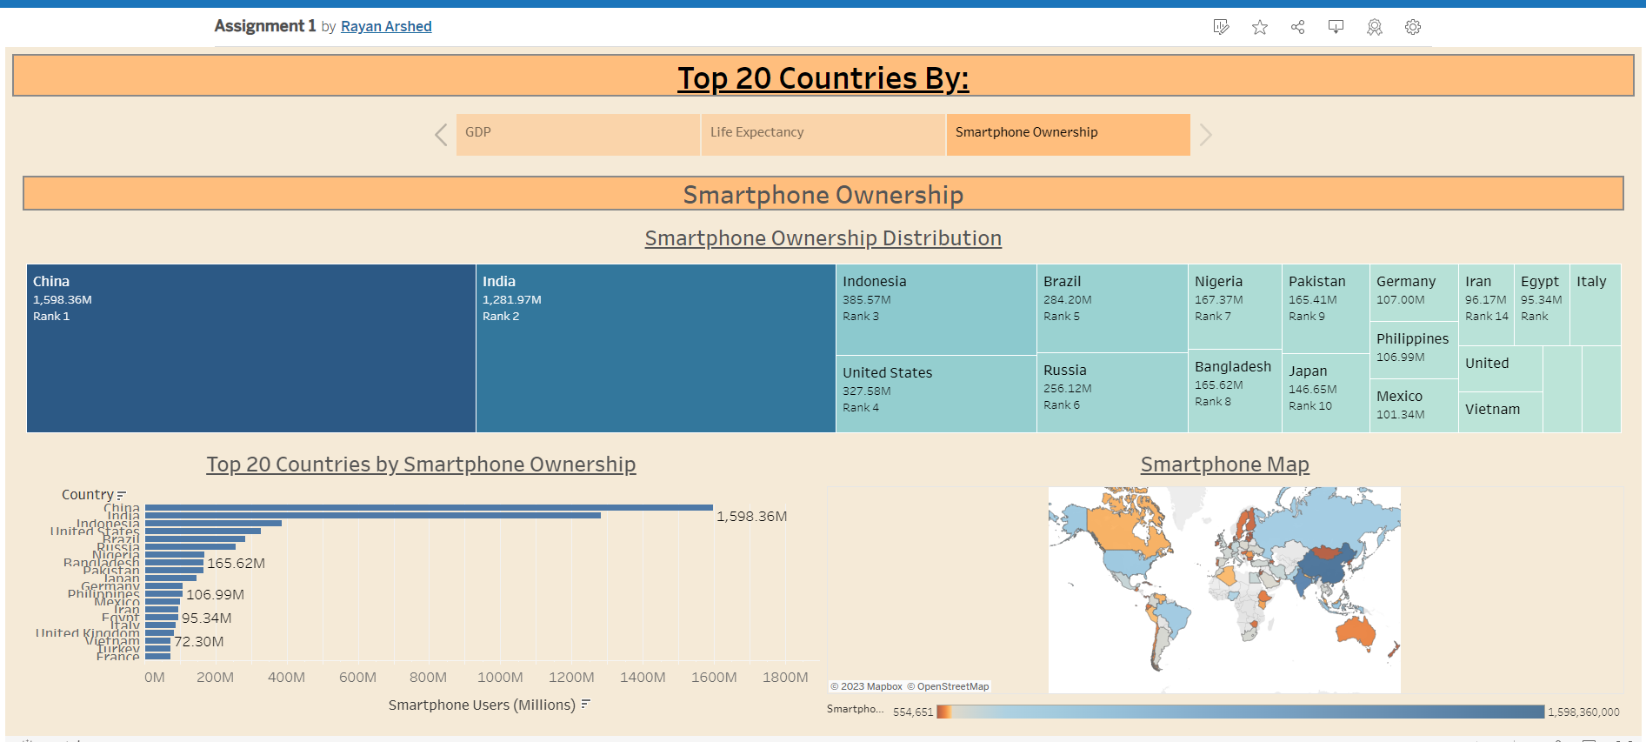

However as the informaiton is displayed correctly and nicely when fullscreen, I believe this is acceptable. With this done, my dashboards and story are complete, hopefully to the client’s desired specifications.

The dashboard created focuses on breaking down the key areas of the dataset, while focusing on the top 20 countries per category, which should enlighten the client on their desired requirements and their request, which focused on those specific ranks for the data set. This should meet their criteria, and be what they requested, without including irrelevant information that would not satisfy their requests with this dataset, such as underpeforming countries as an example. With the crieteria satisified to the best of my ability, I believe that development of the dashboard is now fully complete.

# Reflective

Reflecting on this project, I feel that this has been a success for me as I believe that I have met the requirements for the excel tasks well, by completing features such as macro buttons, and creating figures within excel. I also believe that I have performed well for when it comes to the usage of Tableau, as I believe I followed the data analyst workflow directly, did what was requested of me, while still being cautious with my work in order to make sure I met the hypothetical clients’ request. Specifically making sure my colour scheme is accessible and that nothing would be obscured to any end user is something I believe I performed exceedingly well in. I also feel proud of my documentation for all my steps, as I believe I detailed my procedure for completing my work in a detailed manner as required, with included images and instructions for every stage.

In terms of improvement to my work and results, while I believe that the Excel requirements were fully achieved, and while I am proud of my work in Tableau, if I were to be extremely critical of myself, I do feel that there could have been more room for growth and improvement within the software. While the data provided did not, at least to me, seem to have much complexity that could have been touched upon, I do feel like there may have been some types of figures or methods like calculated fields that I could have experimented with. I did consider creating a scatter graph to compare measures against each other, such as Smartphone Ownership vs GDP, however I found the graphs to be convoluted from early testing, and while pondering whether to create a calculated field, I could not think of what I could potentially create. As I discussed in an earlier section, I feel that if the dataset contained more fields and columns, then potentially I could have created a calculated field and used that in my analysis, however with the data available to me, I did not approach or attempt the subject. I also feel that I could have added some improvements to my final dashboard on Smartphone Ownership too; while I do like the final outcome and design for that dashboard, I do feel that there are some limitations to its presentation when on smaller screens, and while the tree map figure I believe looks very pleasing, I do think that with some more research and experimentation, the formatting could have been improved to cause less conflicts of available space.

Despite these critical thoughts on improvement and areas to consider going forward, I do believe that I achieved the success criteria of this assignment to the best of my abilities, and the process of completing this assignment taught me a lot, especially in accessibility design and consideration of client requests. To conclude, I would consider this assignment a great success in deepening my understanding of Excel and Tableau, in gaining an appreciation for accessible design, and finally for teaching me the basic workflow required by a data analyst.